Approved by  President of Kyiv Athletics Federation  ____________  Hriniuk V.R.  Approved by  Director of Department of youth and sports of the executive body of Kyiv City Council (KCSA)  ____________  Hutsait V.M. |  | Approved by  Director of NGO "Run Ukraine"  _______________  Chernitskyi D.L.

«11th Wizz Air Kyiv City Marathon 2020»
Regulations

1. Date, Time and Location
Date: 31 October -01 November 2020
Time: 08:00 a.m. - 01:00 p.m. on October 31, 2020
01:00 p.m. - 05:30 p.m. on October 31, 2020
07:00 a.m. - 03:30 p.m. on November 01, 2020
Location: Kyiv, 15 Volodymyrska str.
Start and finish points: Kyiv, 15 Volodymyrska str.

2. Race Objectives
«Wizz Air Kyiv City Marathon 2020» (hereinafter - the Race) is held to popularize and promote mass running events in Ukraine, as well as:
- to popularize and promote healthy lifestyle
- to develop mass sports
- to integrate Ukraine into the global marathon movement
- to inform, nurture and motivate Ukrainian public, to facilitate achievement of personal and athletic goals, to stimulate growth of sports achievements among the country's wide grass-root population.

3. Organizers, Patronage and Sponsors
NGO "Run Ukraine" serves as the Race Organizer.
Under the patronage of:
- Kyiv Athletics Federation
- Department of family, youth and sports of the executive body of Kyiv City Council (KCSA)

The Organizing Committee consists of:
- Race Director, Chernitskyi D.L.;
- Project Manager, Tretiakov I.O.;
- Director of the Department of youth and sports of the executive body of Kyiv City Council (KCSA) Hutsait R.M.;
- Kyiv Athletics Federation, Federation President Hriniuk V.R.;
- Head of emergency medical support - Vershyhora A.V.;
- Head Referee of the Race - Pavlos R.M.;
- Main Doctor of the Race - Permiakov P.V.;
- Athletes Manager - Lishchynska I.A.

4. The Race Program
Starter's packages will be distributed to the participants on October 30-31, 2020 at the fall SportExpoUA 2020 at the address NC “Expocenter of Ukraine” (VDNG), pavilion 19.
Please, notice! There will be no distribution of starter’s packages on November 01, 2020.

October 31, 2020 - NC “Expocenter of Ukraine” (VDNG), pavilion 9
08:00 a.m. - Opening of the Race Village
08:00 a.m. - 01:00 p.m. - Luggage storage available
01:00 p.m. - Closing of the Race Village

October 31, 2020
01:00 p.m. - Opening of the Race Village, 15 Volodymyrska str.
01:00 p.m. - 05:30 p.m. - Luggage storage available
01:30 p.m. - Warm-up for adults
02:00 p.m. - Start Kyiv Run 10 km, Team 4х10 km
04:10 p.m. - Start Mini Marathon 4.2 km, Security Cup
04:20 p.m. – Award ceremony Kyiv Run 10 km;
04:50 p.m. – Award ceremony Mini Marathon 4.2 km;
05:30 p.m. - Closing of the Race Village

October 31:
07:00 a.m. - Opening of the "Race Village", 15 Volodymyrska street;
08:00 a.m. - 03:30 p.m. - Luggage storage service available;
08:30 a.m. - Warm-up for adults
09:00 a.m. - Start on the courses 42.195 km, relay 3x10+1x12.195 km, relay 2x21.0975 km;
10:30 a.m. – Start on the course 21.0975 km: Elite, block 1:29, 1:39
10:35 a.m. – Start on the course 21.0975 km: block 1:49, 1:59
10:40 a.m. – Start on the course 21.0975 km: block 2:09, 2:19
12:15 p.m. - Award ceremony for winners and medalists on the 21 km course;
12:30-12:40 p.m. - Award ceremony Wizz Air Kyiv City Marathon 42 km in absolute championship (men), Relays, City Cup, The biggest running club
01:00 p.m. - Award ceremony Wizz Air Kyiv City Marathon 42 km in absolute championship (women)
02:45 p.m. - Award ceremony Wizz Air Kyiv City Marathon 42 km (age groups)
03:30 p.m. - Closing of the "Race Village"

You must arrive at 15 Volodymyrska str. one hour before your race to make sure you have enough time to change, leave your things in the luggage storage, find your starting block and warm up.

5. Race Entry Conditions
Participants may enter the Race in case they provide all the documents upon receiving the starter's package:
- A starter's letter printed out and signed by the participant (the starter's letter can be found in the personal profile or in the e-mail box after a successful payment);
- An ID certifying the age of the participant (required for all participants);
- Document certifying the participant’s right to free participation in the Race or to discount registration fee.

Participants who are 13 years old (for the courses of 4.2 km and 5 km) and 15 years old (for the 10 km course) must also submit Consent from the parents (legal representatives) for participation of a minor on the courses of 4.2 km, 5 km, 10 km or relay (Annex 2 or Annex 3 respectively).
All registered participants bear sole responsibility for their own lives and health regarding the competition, and sign appropriate statement.

Please, notice!
- Starter's package and participant's race bib number will not be provided in case of failure to provide a proper ID;
- Only participants aged 18 or older are admitted to the course of 21.0975 km. The age of a participant is determined according to Race Regulations of NGO “Run Ukraine”.

6. Courses and Routes
The route of the courses 42.195 km and 42.195 km (relay) runs across Kyiv city.
Track surface 97% - blacktop, 3% - paving.
Total elevation gain - 669 meters.
The start and finish points of all courses are located in the same spot.
Please, notice! The routes may be altered!

The route of the 42.195 km course, relay 3x10+1x12.195 km, relay 2x21.0975 km
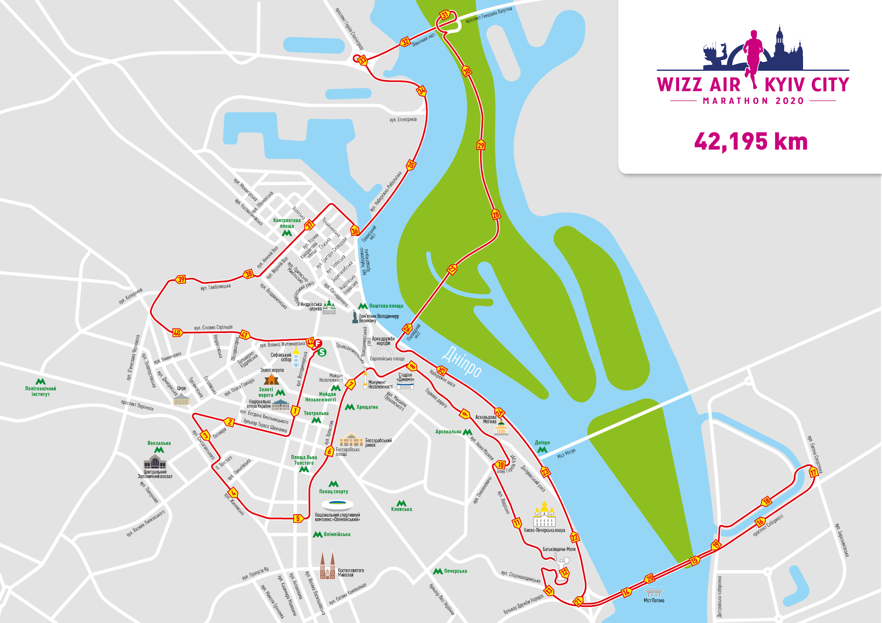

The route of the 21.0975 km course, Team 4x21.0975 km, Team 2x21.0975 km
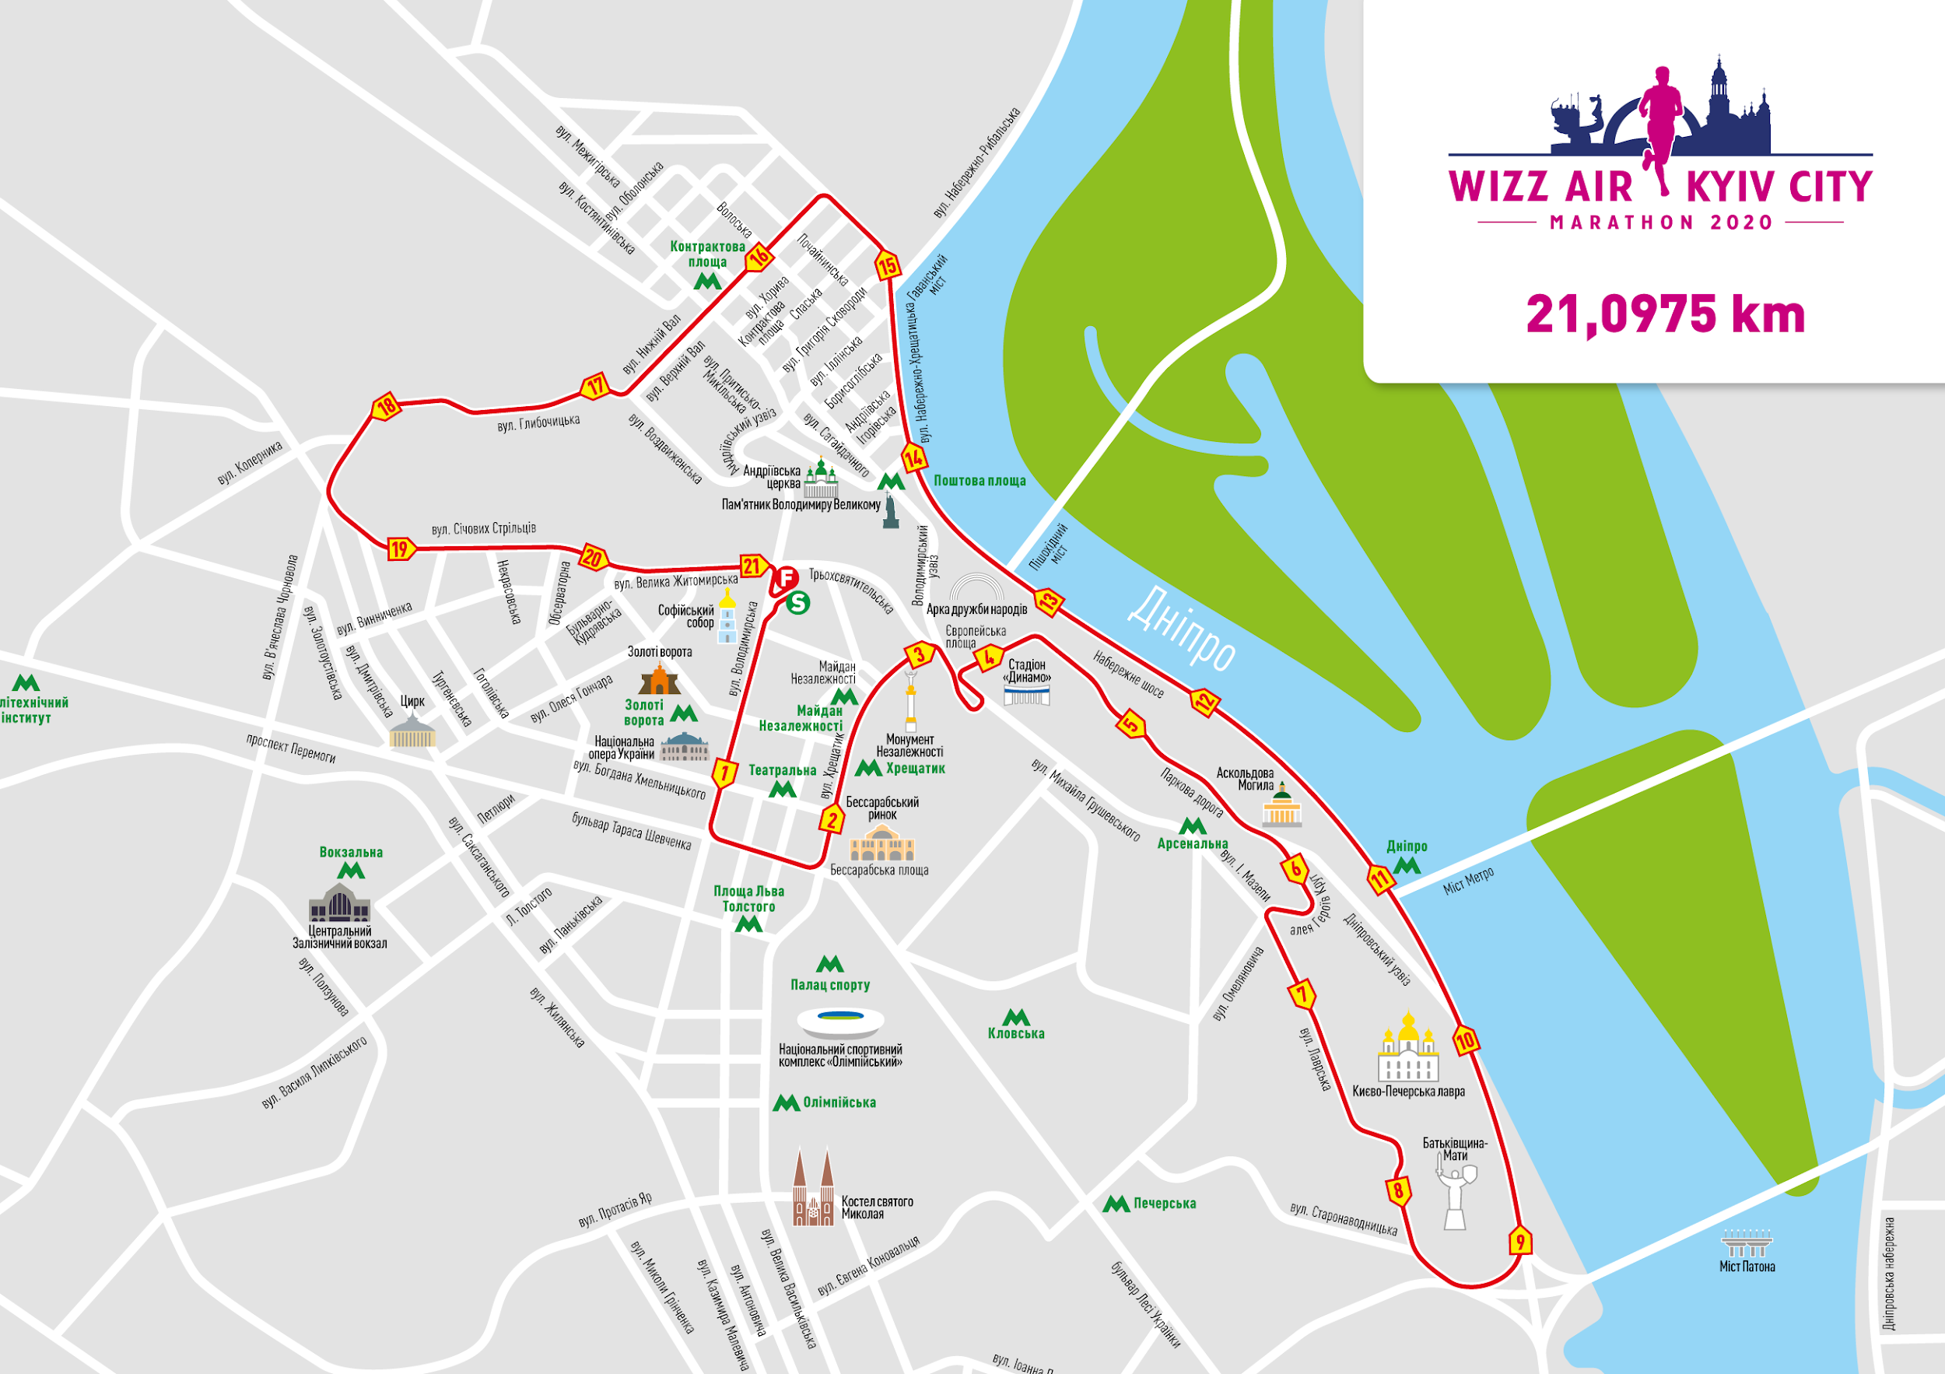

The route of the 10 km course, Team 4x10 km
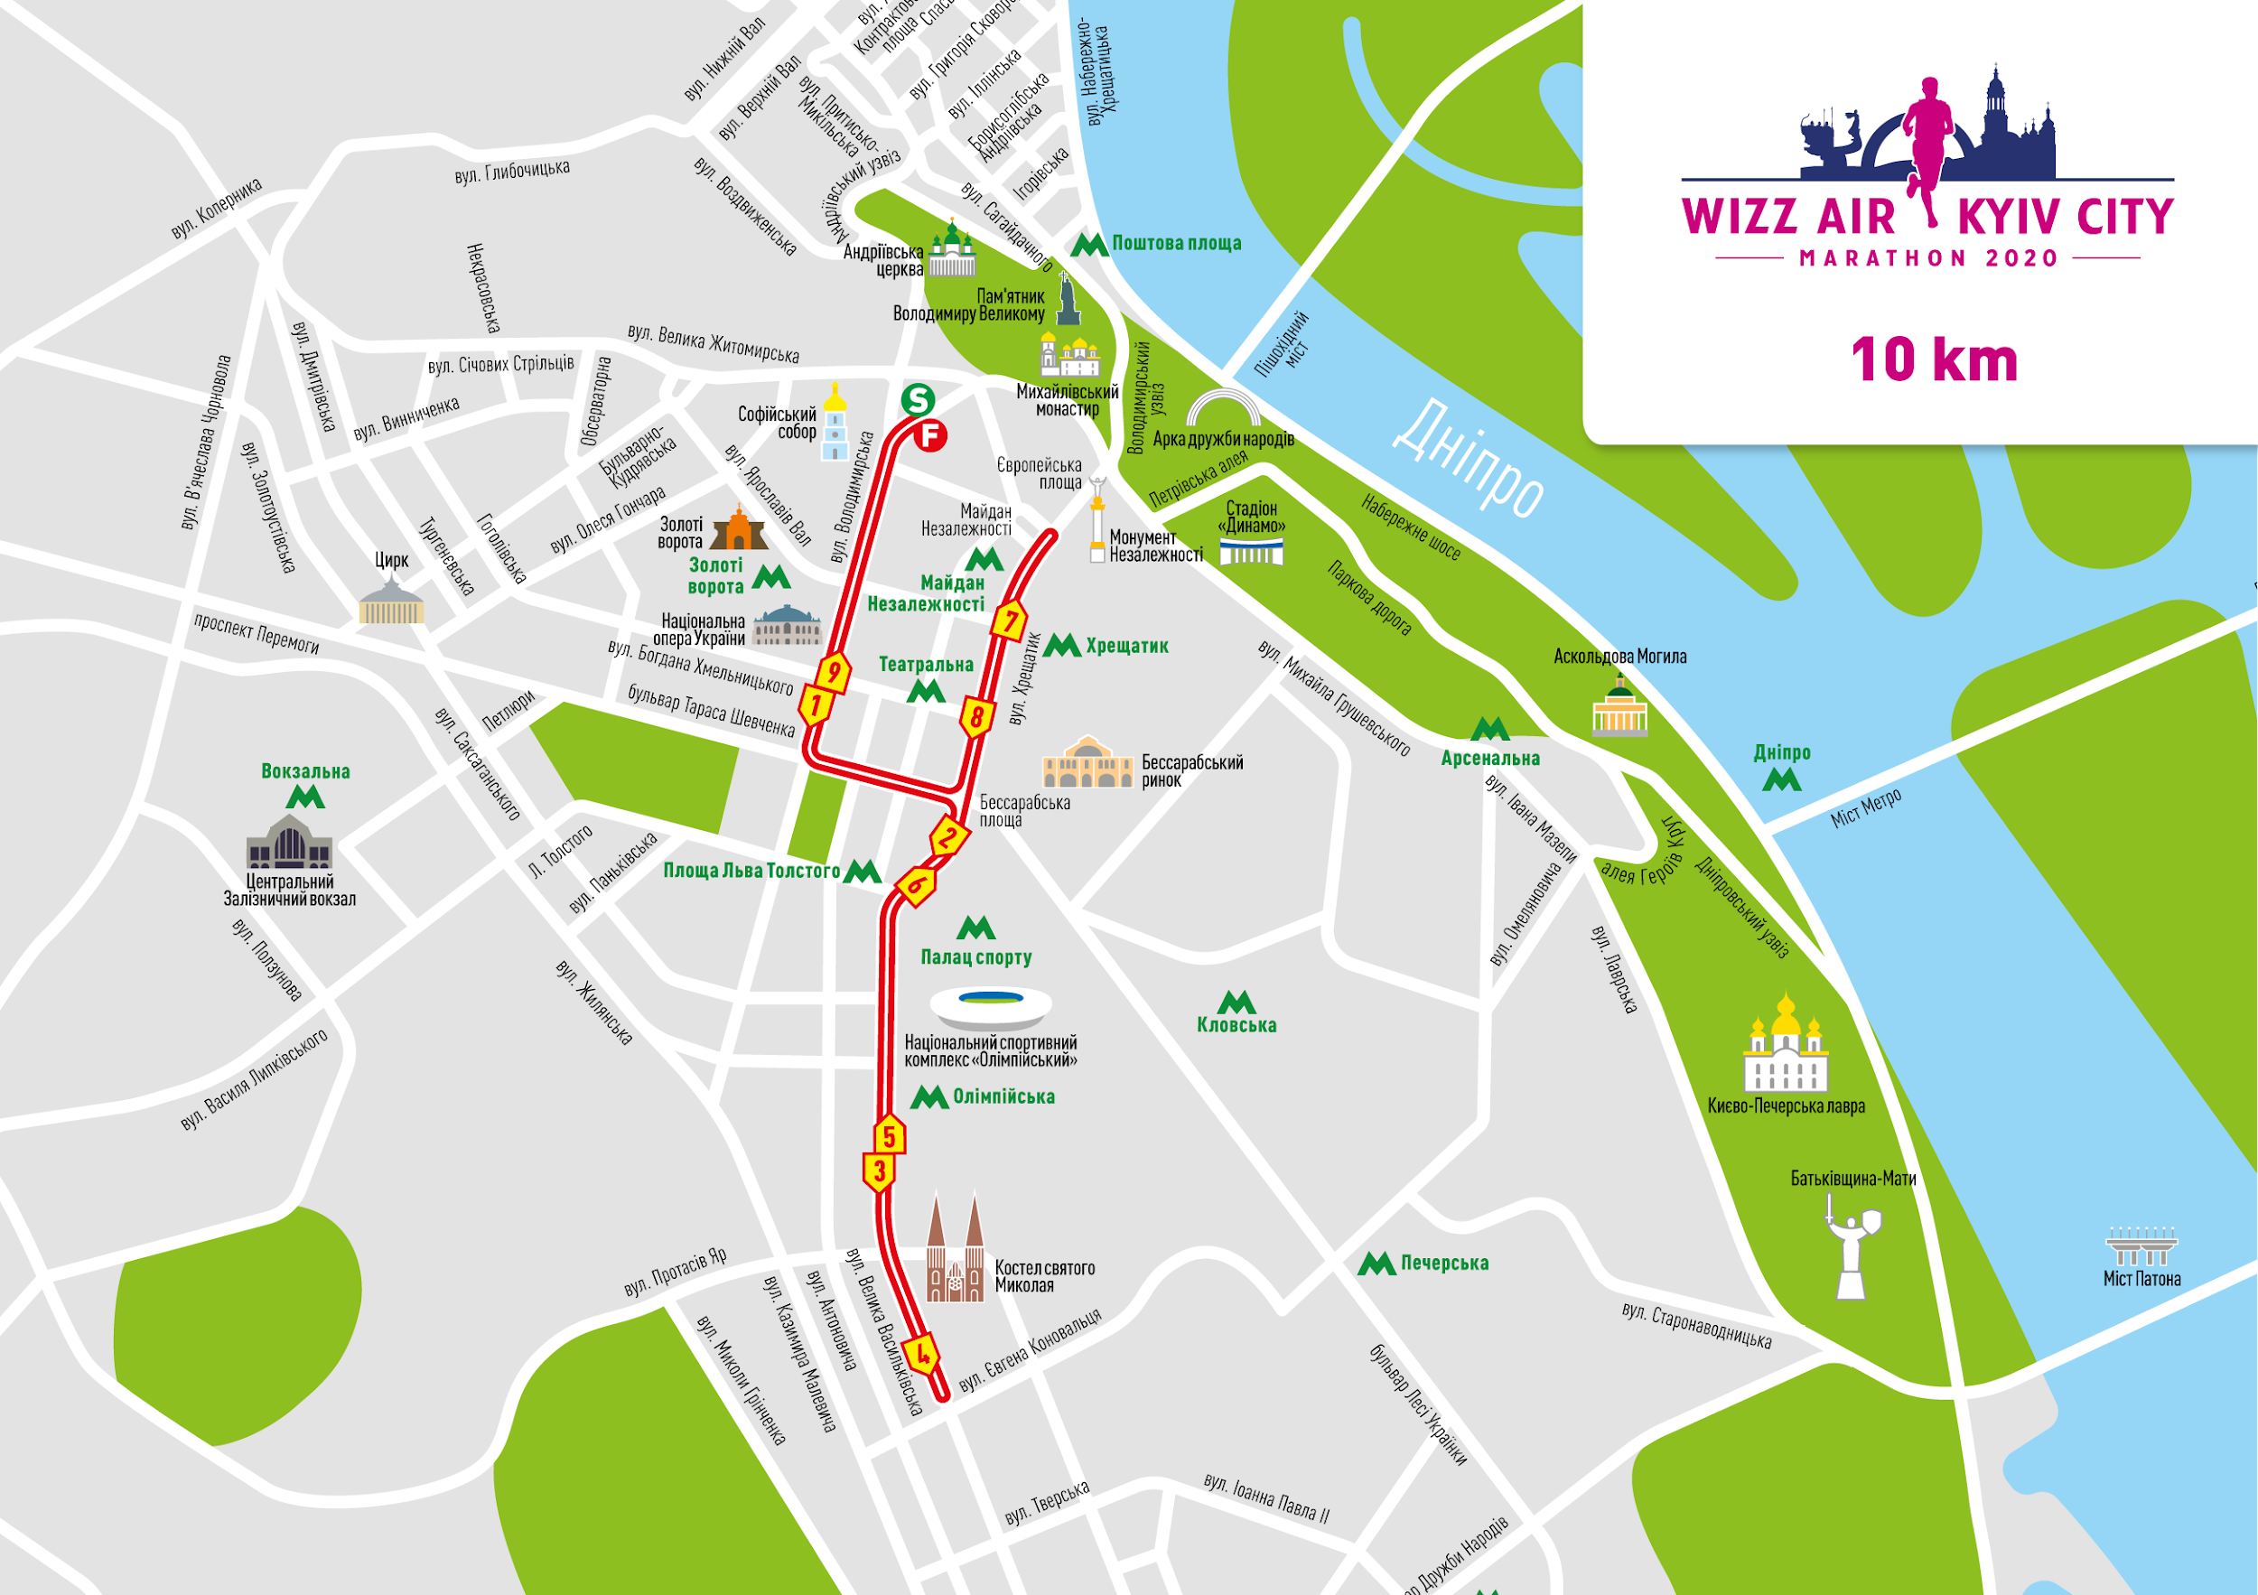

The route of the 4.2 km course, Security Cup:
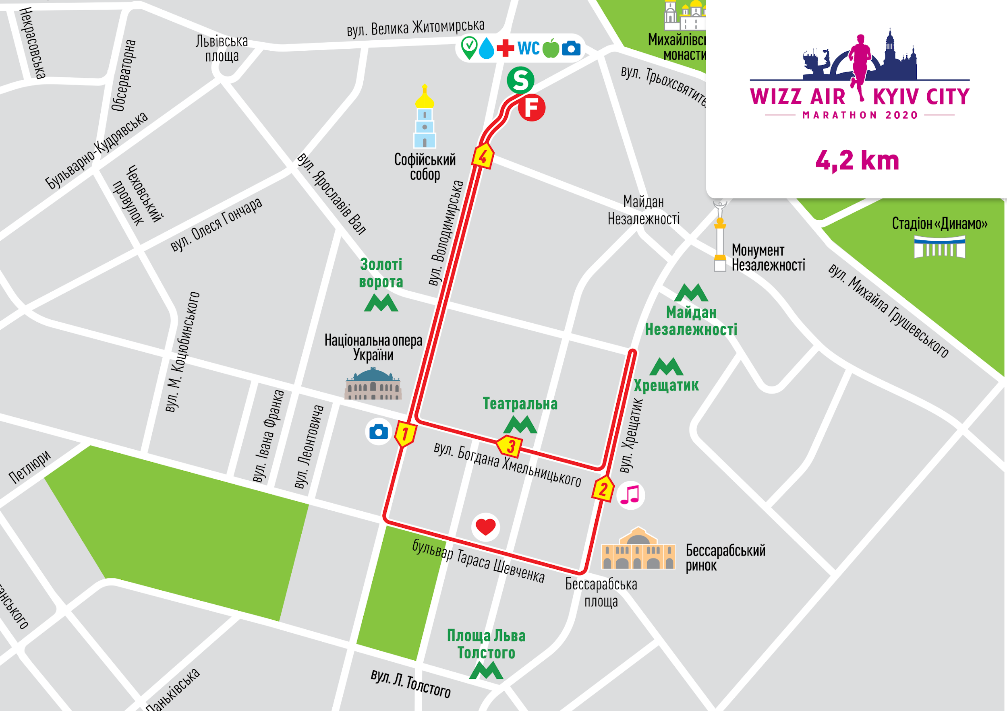

*Information is to be added later

7. Registration for the Race and distribution of the starter’s packages
Participants are allowed to enter the Race provided proper and timely registration for the Race.
Registration is available on-line on the Organizer's website http://kyivmarathon.org/
Online registration of participants is open from 11 December 2019 through 31 October 2020 (in case of available slots).
There will be no registration on the day of the Race.
The Organizer of the Race has the right to suspend or completely close registration without any prior notification in case of reaching the established limit of participants.
A participant is considered registered if an application is filled out.
The registration is considered cancelled in case submitted data is inaccurate and/or false.

7.1. The starter’s package may be received by the third party in case the following documents are presented:
- Document certifying identity of a person receiving the starter’s package (passport, driver’s license etc.)
- Copy of documents certifying identity of a person who purchased registration for the event
- Starter’s letter signed by the person who purchased registration for the event
- Signed statement from the person who purchased registration with the following text:

To the director of NGO “Run Ukraine”
Chernitskyi D.L.
I, (first name and last name of the person who purchased registration in the event), ask you to give my starter’s package with my race bib number (provide the race number) to my representative (first name and last name of the person receiving the starter’s package) due to the fact that I am unable to receive it in person in due time.
Date and signature of the person who purchased registration in the event.

8. Entry Fee
Entry fee for the course of 42.195 km at stage 1 - 488 slots: 890 UAH for members of NGO and the basic registration fee is 1110 UAH;
Entry fee for the course of 42.195 km at stage 2 - 1586 slots: 990 UAH for members of NGO and the basic registration fee is 1230 UAH;
Entry fee for the course of 42.195 km at stage 3 - 366 slots: 1090 UAH for members of NGO and the basic registration fee is 1400 UAH

Entry fee for the course of 21.0975 km at stage 1 - 856 slots: 710 UAH for members of NGO and the basic registration fee is 885 UAH;
Entry fee for the course of 21.0975 km at stage 2 - 2782 slots: 840 UAH for members of NGO and the basic registration fee is 1050 UAH;
Entry fee for the course of 21.0975 km at stage 3 - 642 slots: 940 UAH for members of NGO and the basic registration fee is 1175 UAH

Entry fee for the course of 10 km at stage 1 - 360 slots: 620 UAH for members of NGO and the basic registration fee is 775 UAH
Entry fee for the course of 10 km at stage 2 - 1170 slots: 700 UAH for members of NGO and the basic registration fee is 875 UAH
Entry fee for the course of 10 km at stage 3 - 270 slots: 800 UAH for members of NGO and the basic registration fee is 1000 UAH

Entry fee for the course Team 4x10 km at stage 1 - 4 slots: 2480 UAH for members of NGO and the basic registration fee is 3100 UAH
Entry fee for the course Team 4x10 km at stage 2 - 24 slots: 2800 UAH for members of NGO and the basic registration fee is 3500 UAH
Entry fee for the course Team 4x10 km at stage 3 - 4 slots: 3200 UAH for members of NGO and the basic registration fee is 4000 UAH

Entry fee for the course of 4.2 km at stage 1 - 190 slots: 550 UAH for members of NGO and the basic registration fee is 685 UAH
Entry fee for the course of 4.2 km at stage 2 - 618 slots: 600 UAH for members of NGO and the basic registration fee is 750 UAH
Entry fee for the course of 4.2 km at stage 3 - 143 slots: 650 UAH for members of NGO and the basic registration fee is 810 UAH

Entry fee for the course Nordic Walk 4.2 km at stage 1 - 8 slots: 550 UAH for members of NGO and the basic registration fee is 685 UAH
Entry fee for the course Nordic Walk 4.2 km at stage 2 - 27 slots: 600 UAH for members of NGO and the basic registration fee is 750 UAH
Entry fee for the course Nordic Walk 4.2 km at stage 3 - 6 slots: 650 UAH for members of NGO and the basic registration fee is 810 UAH

Entry fee for the course of 4x21.0975 km at stage 1 - 1 slot: 2840 UAH for members of NGO and the basic registration fee is 3540 UAH
Entry fee for the course of 4x21.0975 km at stage 2 - 6 slots: 3360 UAH for members of NGO and the basic registration fee is 4200 UAH
Entry fee for the course of 4x21.0975 km at stage 3 - 1 slot: 3760 UAH for members of NGO and the basic registration fee is 4700 UAH

Entry fee for the course of 2x21.0975 km at stage 1 - 2 slots: 1420 UAH for members of NGO and the basic registration fee is 1770 UAH
Entry fee for the course of 2x21.0975 km at stage 2 - 3 slots: 1680 UAH for members of NGO and the basic registration fee is 2100 UAH
Entry fee for the course of 2x21.0975 km at stage 3 - 2 slots: 1880 UAH for members of NGO and the basic registration fee is 2350 UAH

Entry fee for the relay 2x21.0975 km at stage 1 - 6 slots: 1420 UAH for members of NGO and the basic registration fee is 1770 UAH
Entry fee for the relay 2x21.0975 km at stage 2 - 20 slots: 1680 UAH for members of NGO and the basic registration fee is 2100 UAH
Entry fee for the relay 2x21.0975 km at stage 3 - 4 slots: 1880 UAH for members of NGO and the basic registration fee is 2350 UAH

Entry fee for the relay 3x5+1x6.0975 km at stage 1 - 6 slots: 2840 UAH for members of NGO and the basic registration fee is 3540 UAH
Entry fee for the relay 3x5+1x6.0975 km at stage 2 - 18 slots: 3360 UAH for members of NGO and the basic registration fee is 4200 UAH
Entry fee for the relay 3x5+1x6.0975 km at stage 3 - 6 slots: 3760 UAH for members of NGO and the basic registration fee is 4700 UAH

The entry fee does not include the bank fee for the money transfer.
The entry fee is to be paid by the Race participant by electronic payment on the organizer’s website runukraine.org.

9. Starter's Packages, Receiving Starter's Packages
The starter's packages will be distributed on October 30- 31, 2020 at SportExpoUA at the address NC “Expocenter of Ukraine” (VDNG), pavilion 19.

The "starter's package" of a participant on the courses of 42.195 km includes:
- Race bib number with participant's name (for those registered by 30 September 2020)
- Accident insurance covering participation in sports competitions on the day of the Race
- Finisher's medal (awarded if the course is finished within the time limit)
- Wizz Air voucher 20 euro worth
- Results capturing electronic chip
- Thermal blanket at the finish line
- Plastic backpack
- Plastic top for the Start
- Buff
- Map of the route
- Wizz Air Kyiv City Marathon Participant’s Guide
- Official event wristband
- Finisher's package: an apple, a banana, water
- Pictures after the race
- Online diploma with the result
- Changing rooms and luggage storage service (changing rooms open from 08:00 a.m. until 04:00 p.m.)
- Food stations at 15; 21; 25; 30; 35; 40 km and at the finish line
- Hydration stations at 5; 10; 15; 21; 25; 27.5; 30; 32.5; 35; 37.5; 40 km and at the finish line
- Special offers from our partners
- Music along the route
- Massage at the finish
- Admission to sport goods exhibition SportExpoUA 2020

The "starter's package" of a participant on the courses of 21.0975 km includes:
- Race bib number with participant's name (for those registered by 30 September 2020)
- Accident insurance covering participation in sports competitions on the day of the Race
- Finisher's medal (awarded if the course is finished within the time limit)
- Wizz Air voucher 20 euro worth
- Results capturing electronic chip
- Thermal blanket at the finish line
- Plastic backpack
- Plastic top for the Start
- Changing rooms and luggage storage service (changing rooms open from 08:00 a.m. until 04:00 p.m.)
- Food stations at 15 km and at the finish line
- Hydration stations at 5; 10; 15 km and at the finish line
- Online diploma with the result
- Map of the route
- Wizz Air Kyiv City Marathon Participant’s Guide
- Special offers from our partners
- Music along the route
- Official event wristband
- Finisher's package: an apple, a banana, water
- Refreshment stations along the route
- Pictures after the race
- Massage at the finish
- Admission to sport goods exhibition SportExpoUA 2020

The "starter's package" of a participant of the relay 3x10+1x12.195 km includes:
- Race bib number with participant's name (for those registered by 30 September 2020) - 4 pcs
- Accident insurance covering participation in sports competitions on the day of the Race - 4 pcs
- Finisher's medal (awarded if the course is finished within the time limit) - 4 pcs (1 set)
- Wizz Air voucher 20 euro worth - 4 pcs
- Result capturing electronic chip - 1 pcs
- Thermal blanket at the finish line - 4 pcs
- Plastic backpack - 4 pcs
- Plastic top at the Start - 4 pcs
- Changing rooms and luggage storage service (changing rooms open from 08:00 a.m. until 04:00 p.m.)
- Food stations at 15 km and at the finish line
- Hydration station at 5; 10;15 km and at the finish line
- Online diploma with the result
- Map of the route - 4 pcs
- Wizz Air Kyiv City Marathon Participant’s Guide - 4 pcs
- Special offers from our partners
- Music along the route
- Official event wristband - 4 pcs
- Finisher's package: an apple, a banana, water
- Refreshment stations along the route
- Pictures after the race
- Massage at the finish
- Admission to sport goods exhibition SportExpoUA 2020

The "starter's package" of a participant of the relay of 2х21.0975 km includes:
- Race bib number with participant's name (for those registered by 30 September 2020) - 2 pcs
- Accident insurance covering participation in sports competitions on the day of the Race - 2 pcs
- Finisher's medal (awarded if the course is finished within the time limit) - 2pcs (1 set)
- Wizz Air voucher 20 euro worth - 2 pcs
- Results capturing electronic chip - 1 pcs
- Thermal blanket at the finish line - 2 pcs
- Plastic backpack - 2 pcs
- Plastic top at the Start - 2 pcs
- Changing rooms and luggage storage service (changing rooms open from 08:00 a.m. until 04:00 p.m.)
- Food stations at 15 km and at the finish line
- Hydration stations at 5; 10;15 km and at the finish line
- Online diploma with the result
- Map of the route - 2 pcs
- Wizz Air Kyiv City Marathon Participant’s Guide - 2 pcs
- Special offers from our partners
- Music along the route
- Official event wristband - 2 pcs.
- Finisher's package: an apple, a banana, water
- Refreshment stations along the route
- Pictures after the race
- Massage at the finish
- Admission to sport goods exhibition SportExpoUA 2020

The "starter's package" of a participant on the course of 10 km includes:
- Race bib number with participant's name (for those registered by 30 September 2020)
- Accident insurance covering participation in sports competitions on the day of the Race
- Finisher's medal (awarded if the course is finished within the time limit)
- Wizz Air voucher 20 euro worth
- Result capturing electronic chip
- Plastic backpack
- Plastic top at the Start
- Changing rooms and luggage storage service
- Hydration stations at 5 km and at the finish line
- Map of the route
- Wizz Air Kyiv City Marathon Participant’s Guide
- Special offers from our partners
- Music along the route
- Official event wristband
- Finisher's package: an apple, a banana, water, refreshment stations along the route
- Pictures after the race;
- Massage at the finish
- Admission to sport goods exhibition SportExpoUA 2020

The "starter's package" of a participant on the course of 4.2 km, Security Cup includes:
- Race bib number with participant's name (for those registered by 30 September 2020)
- Accident insurance covering participation in sports competitions on the day of the Race
- Finisher's medal (awarded if the course is finished within the time limit)
- Wizz Air voucher 20 euro worth
- Result capturing electronic chip
- Plastic backpack
- Changing rooms and luggage storage
- Food station at the finish line
- Map of the route
- Wizz Air Kyiv City Marathon Participant’s Guide
- Special offers from our partners
- Music along the route
- Official event wristband
- Finisher's package: an apple, a banana, water
- Pictures after the race
- Massage at the finish
- Admission to sport goods exhibition SportExpoUA 2020

Participants are to pick up starter's packages in person upon presenting the starting letter and ID.
Participants that failed to join the Race can obtain their starter's package within 30 calendar days after the competition at the Organizer’s office, having preliminary sent notification about their intention to do so by e-mail: registration@runukraine.org. They also can place a request to have it delivered to a specified address.
Delivery of starter's packages is done at the expense of the participant. If possible, the Organizer arranges for partners to provide free delivery.

10. Athletic team competitions (teams and relay)
Mixed teams from commercial and non-profit organizations consisting of 2 or 4 persons are permitted to participate in the relay. Participation of a different number of people would lead to immediate disqualification.
If the organization can not find 4 (2) members from inside organization, it can invite volunteers.
In the relay race participation of all four team members is mandatory.
The team is considered registered if its representative filled out the application, registration form and paid the entry fee for the team.
Each participant is assigned a particular relay stage at registration. The order of participants can be changed through October 31, 2020 in your personal profile on the website runukraine.org.
For participant’s information:
- During the relay race the procedure of baton transfer should take place only in the relay transfer zone.
- Each team gets ONE result capturing electronic chip
- The chip is attached to the leg and passed to the next participant in the relay transfer zone
- The first participant starts with the chip attached to his/her leg
- Team members are not allowed to exchange numbers (especially relay team members)
- Finisher’s medals for all stages are presented to the participant of the last stage upon crossing the finish line
- Finisher’s packages (a banana, an apple) are given to each participant upon finishing their stage of relay
Infringement of any of the above rules will result in disqualification of the entire team.
The result of the last participant at the finish of the fourth stage of the relay is considered to be the result of the relay.
The result of the team scoring is the sum of the official results of all four (or two) team members.
Payment for participation in the corporate relay is performed by bank transfer on the basis of invoice issued by the Organizers. Documents confirming the payment should be sent to the email registration@runukraine.org no later than 10 days prior to the event. All questions in regard to organization of corporate relay are to be sent to the email address registration@runukraine.org.

10.1 For corporate teams:
There are several options of participation for companies:
- Team participation (any course and any number of participants);
- Business Cup (relay 3x10 km + 1x12.195 km)
- Diplomat Cup (relay for employees of diplomatic organizations)

Business Cup:
Mixed teams from commercial and non-profit organizations are permitted to participate in the relay.
Organization may form one or more teams for a corporate relay. Number of teams from one organization is unlimited.
Winners in five business segments will be awarded within the Business Cup, with a separate ranking on the event website. Company’s name will be placed on the Business Cup participants’ bib number.

Attention!
- There will be no awarding among teams that ranked 1, 2 and 3 places in Business Cup.
- Business Cup teams will also take part in the overall ranking of relay teams.
- If a segment consists of less than 5 teams, there will be no awarding in this segment, the team will take part only in the overall scoring.

Security Cup - 4.2 km:
Mixed teams of commercial and non-profit organizations (from the field of civil security) are permitted to participate in the race:
- Free participation
- Maximum number of participants in a team - 4 people
- Maximum number of teams from one non-profit organization - 3 teams
- Total number of participants - 48 people (12 teams)
According to the results, winners of Security Cup will be determined and there will be awards for the teams that ranked 1, 2 and 3 places.
According to the results, the winning team will be determined and will be rewarded for the 1st place in this category.
Also Security Cup teams will take part in the overall ranking among men and women on the 4.2 km course.

For questions regarding terms of registration, please email registration@runukraine.org
Contact person: Liubov Belichenko+380674074013

11. Food and Hydration Stations
Food stations and hydration stations are located at 5; 10; 15; 21; 25; 27.5; 32.5; 35; 37.5; 40 km and at the finish line. They have water, medical care, food, toilets and volunteer assistance available.

12. Award ceremony
42.195 km course:
For the 42.195 km course the award is given to those winning places 1 through 5 among men and women in absolute championship.
The official time used to determine the overall ranking among men and women is the Gun Time.

Prize scale (currency – US dollar (USD), using NBU exchange rate on the day of the Race):
Place | Men | Women
1 | 2500 | 2500
2 | 1200 | 1200
3 | 800 | 800
4 | 500 | 500
5 | 300 | 300

For the 42.195 km course the award is given in age groups, places 1 through 3:
Men: 18-22, 23-29, 30-39, 40-49 50-59, 60-69, 70 and older
Women: 18-22, 23-29, 30-39, 40-49, 50-59, 60-69, 70 and older
The age group is assigned based on the age of the participant as of December 31 of the current year. The participants awarded in absolute championship cannot be awarded in age groups. In age groups the places are distributed according to Net Time.
Award winners and medalists receive monetary rewards and prizes.
Prize scale (currency - hryvnia, UAH)
Age groups | Men |  |  | Women
 | 1st place | 2nd place | 3rd place | 1st place | 2nd place | 3rd place
18-22 | 1800 | 1500 | 1000 | 1800 | 1500 | 1000
23-29 | 1800 | 1500 | 1000 | 1800 | 1500 | 1000
30-39 | 1800 | 1500 | 1000 | 1800 | 1500 | 1000
40-49 | 1800 | 1500 | 1000 | 1800 | 1500 | 1000
50-59 | 1800 | 1500 | 1000 | 1800 | 1500 | 1000
60-69 | 1800 | 1500 | 1000 | 1800 | 1500 | 1000
70+ | 1800 | 1500 | 1000 | 1800 | 1500 | 1000

Please, notice:
- the winners in absolute championship on the course of 42.195 km places 1 through 5 among men and women cannot be awarded in age groups
- Participants participating in wheelchairs or using any other mechanical device on the course may not be awarded in absolute championship or in age groups on any course

Prize scale for Kyiv Open Marathon Cup for citizens of Ukraine (currency – US dollars (USD), using NBU exchange rate on the day of the Race):
Place | Men | Women
1 | 500 | 500
2 | 400 | 400
3 | 300 | 300
4 | 200 | 200
5 | 100 | 100

Bonus for setting time: 1000 US dollars for each category (men and women). Men: 2:22:00, Women: 2:45:00 .

21.0975 km
For the 21.0975 km course the award is given to those winning places 1 through 5 among men and women in absolute championship. Participants on the 21.0975 km course will be starting in blocks with 5-minute intervals with a separate Gun Time for each block but with one overall ranking among men and women respectively.
Winners and medalists receive memorable prizes

Relay 3x10+1x12.195 km
On the relay course 3х10+1х12.195 km, including Business Cup, the teams are awarded in absolute championship, places 1 through 3.
Winners and medalists receive monetary rewards and memorable prizes.
10,000 UAH is awarded to the team winning the 1st place.
6,000 UAH is awarded to the team winning the 2nd place.
4,000 UAH is awarded to the team winning the 3rd place.
Please, notice! The winning team must come to the Referee Tent upon finishing the course to present identification documents to confirm stated make-up of the team.

Relay 2x21.0975 km
On the relay course 2x21.0975 km the teams are awarded in absolute championship, places 1 through 3.
Winners and medalists receive monetary rewards and memorable prizes.
10,000 UAH is awarded to the team winning the 1st place.
6,000 UAH is awarded to the team winning the 2nd place.
4,000 UAH is awarded to the team winning the 3rd place.

10 km course
On the 10 km course awards are given to those winning places 1 through 3.
The winners and medalists receive memorable prizes.

Course Team 4 х 10 km:
Official time used in calculation of the overall ranking of teams is Gun Time summed for all 4 team members.
On the course 4x10 km awards are given to those taking places 1 through 3.
The winners and medalists receive memorable prizes.
The teams 4x10 km will take part in the overall ranking among men and women on the 10 km course.

4.2 km course
On the 4.2 km course the awards are given to men and women taking places 1 through 3 in absolute championship.
Winners and medalists get memorable prizes.
The official time for calculation of the overall ranking of men and women is the time since the starting gun shot (Gun Time).
Participants in the Security Cup category are included in the overall ranking for men and women on the 4.2 km course.

Nordic Walking 4.2 km course
On the Nordic Walking 4.2 km course the awards are given to men and women taking places 1 through 3 in absolute championship.
Winners and medalists get memorable prizes.
Official time used in calculation of the overall ranking of men and women is Gun Time.

City Cup
The Cup is awarded to those demonstrating the best time on the course 42.195 km among athletes that stated “Kyiv” as their city on the registration form. Men and women are awarded separately.

