Approved by  President of Kyiv City Independent Federation of Roller Sports  ____________  Symonenko O.M.  Approved by  Deputy Director of Education and Science, Youth and Sports Department, Head of Family, Youth and Sports Department of Kyiv.  ___________________________  Trofymov O.S. |  | Approved by  Director of NGO "Run Ukraine"  ________________  Chernitskyi D.L.

Sixth International Nova Poshta Kyiv Half Marathon 2016
Inline Skating
Regulations
1. Date, Time and Location.
Date: April 17, 2016
Time: 9 a.m. - 6 p.m.
Location: Kyiv, Kontraktova Square.
Start and finish points: 4 Kontraktova Square, Kyiv (opposite the restaurant “Puzata Khata”)
2. Competition Objectives.
Nova Poshta Kyiv Half Marathon 2016 Inline Skating (hereafter - the Race) is held to popularize and promote mass roller sports events in Ukraine, as well as:
• to popularize and promote healthy lifestyle
• to develop mass sports
• to integrate Ukraine into the global marathon movement
• to inform, nurture and motivate Ukrainian public, to facilitate achievement of personal athletic goals, to stimulate growth of sports achievements among the country's wide grass-root population.
3. Organizers, Patronage and Sponsors.
NGO "Run Ukraine" serves as the Race organizer.
Under the patronage of:
• Ukrainian Federation of Roller Sports, Kyiv City Independent Federation of Roller Sports
• Department of Family, Youth and Sports of Kyiv City State Administration.
The event is sponsored by:
• Nova Poshta
• Adidas-Ukraine
• Macdonald's Restaurant Chain
• Coca-Cola Beverages Ukraine, BONAQUA TM
The organizer establishes an organizing committee from among its own staff, as well as engages different sport-specific specialists.
The organizing committee approves "The Race Regulations".
The organizing committee includes:
• Race Director, Timofieiev S. O.
• Project Manager, Tretiakov I.O.
• Head of Family, Youth and Sports Department of Kyiv, Trofymov O.S.
• Kyiv City Independent Federation of Roller Sports
• Head Referee of the Race, Nehoda O.
• Head of the Emergency Medical Care, Vershyhora A.V.
The organizing committee approves the Race Regulations, as well as introduces any further changes or addenda to the document.
The organizing committee is responsible for:
• Managing personal data and communication with the participants;
• Raising funds specifically for the purpose of conducting the Race;
• Preparing documents and materials for the Mandate Committee;
• Providing prizes to award winners and medalists of the Race;
• Ensuring the refereeing;
• Leasing sports facilities, premises and technical equipment necessary for conducting the Race;
• Organizing security measures and medical oversight of the Race;
• Controlling organizing and conducting of the Race, dealing with official claims and resolving disputes, as well as reviewing documents and approving entrance to the Race is designated for the Mandate Committee.
The Mandate Committee includes:
• Representative of the organizing committee;
• Head Referee of the Race;
• Chief Secretary of the Race.
Chairman of the Mandate Committee is Timofieiev S. O., Race Director. Professional athletes and sport-specific specialists are admissible to join the Committee.
4. General Rules of the Race.
The Race is organized and conducted under strict adherence to International Regulations for Roller Sports, Technical Regulations of the Race and other relevant resolutions issued by the organizer of the Race. The organizer reserves the right to make changes to the Race program. The organizer guarantees the Race will be run rain or shine, regardless of the weather conditions.
4.1. General Rules
• The organizer reserves the right to cancel the Race, be it before or during the Race, due to unforeseen out of control circumstances;
• The Regulations of the Race is an official document acting as an agreement between the organizer and the participants;
• Any proposals, corrections and additions to this document are to be submitted to the organizer's e-mail: registration@runukraine.org.
4.2. Health Concerns
• Each participant enters the Race on their own will, acknowledging all the possible risks to their health during and after the Race.
• Each participant takes personal responsibility for their physical condition and ability to finish the distance of choice.
• Each participant (registered for 21.0975 km or over) should have a certificate of health and insurance policy (mandatory) valid for the time of the Race.
• Citizens of foreign countries are required to provide health insurance that covers participation in sports activities (certificate of health is not required)
• The organizer is not liable for physical injury, damage, deterioration of physical condition that the participant suffered during the competition;
• The organizer is not responsible for the deterioration of the physical condition of a participant after the competition;
• The organizer of the competition shall not be liable for any damages (loss of or damage to personal belongings), which the participant experienced during the race;
• The organizer of the competition shall not be liable for any loss, damage or other harm caused during the race by participants or spectators of the race.
5. The Race Organizing and Conducting Expenses.
The event expenses are covered by involving sponsors and partners, as well as by entry fees of the participants.
Any traveling, accommodation and food expenses are covered by participants or participants' sending organizations while the organizers arrange for special conditions with hotels, ensuring affordable accommodation rates.
6. Race Courses and Participants Age Restrictions
The race is open to all participants of sport clubs and roller-skating lovers who have a certificate of health stamped and signed by the authorized doctor or sports medicine clinic.
Courses and participant age restrictions:
• 21.0975 km – men and women born in 2002 or earlier
• 5 km – men and women born in 2004 or earlier
Uniform, equipment and protective gear of participants should be correspond the requirements of the General Rules that define the conditions for participation in the competition.
The race is an individual road race.
Age of the participant is determined as of December 31 of the current year
7. The Race Program
Handing out of starter's packages to participants at SportExpoUA 2016:
• from 12 p.m to 8 p.m., April 15, 2016
• from 10 a.m to 8 p.m., April 16, 2016
April 17:
7 a.m. - Opening of the Marathon Village, 4 Kontraktova Square.
8 a.m. - 4 p.m. - Locker service working hours;
9 a.m. - 21.0975 km course, relay 3x5+1x6.0975 start;
11:10 a.m. - Awards Ceremony relay 3x5+1x6.0975;
12:10 p.m. - 21.0975 km course (inline skating) start;
1:15 p.m. - 5 km course (inline skating) start;
1:55 p.m. - 10 km course start;
2:40 p.m. - Award Ceremony 21.0975 km course (inline skating);
2:40 p.m. - Award Ceremony 5 km course (inline skating);
3:00 p.m. - Award Ceremony 10 km course;
3:20 p.m. - 5 km course start;
4:00 p.m. - Award Ceremony 5 km course;
5:00 p.m. - Closing of the Marathon Village
8. Race Entry Conditions
Participants enter the Race under condition of presenting the Mandate Committee all the required documents listed below at the time of receiving their "starter's packages":
• Starter's Letter printed out and signed by the participant (the Starter's Letter can be found in your personal profile or in you e-mail after a payment is successfully made)
• An ID document confirming the participant's identity and age (mandatory for all);
• A document certifying the right for free participation in the Race or for an exemption discount for payment of entry fees.
• Every participant is required to have health insurance that covers accidents during the sports competition, participants registered for 21.0975 km course are also required to provide certificate of health. A complete list of institutions that provide certificate of health is provided in Appendix 1 of the Regulation. Please, notice! Certificates of health issued by other institutions will not be accepted by the Mandate Committee and the Medical Director of the Race.
Please, notice!
• At the absence of an ID document, a start number and a starter's package are not handed out.
• Medical documents provided to the Mandate Committee are not to be returned.
• A photocopy of a certificate of health is accepted by the Mandate Committee only upon presenting the original.
• Medical documents should be issued not earlier than 6 months prior to the Race.
• Only participants who are 14 years old or older are admitted to the 21.0975 km course.
The age is determined as of December 31 of the current year based on the documents submitted on April 15 or 16, 2016 when the starter's packages are handed out at SportExpoUA2016
The overall limit of participants for all courses of inline skating - 150 athletes.
9. Courses and Routes
The race course lies across Kyiv.
Track surface: 100% - blacktop;
Total elevation gain - 100 m.
Starting and Finish lines on all courses are located at the same place.
21.0975 km (inline skating) route:
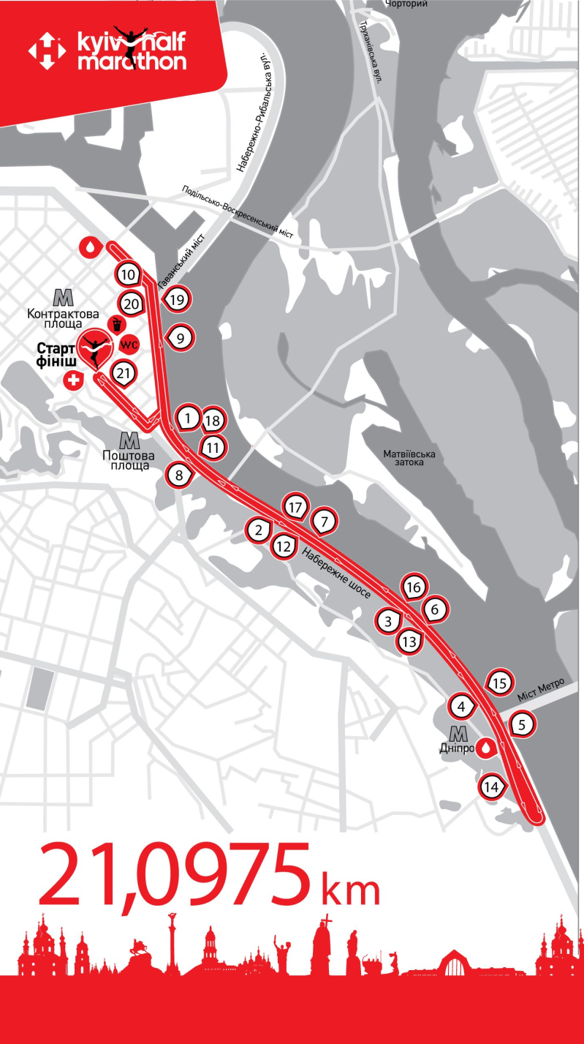

5 km (inline skating) route:
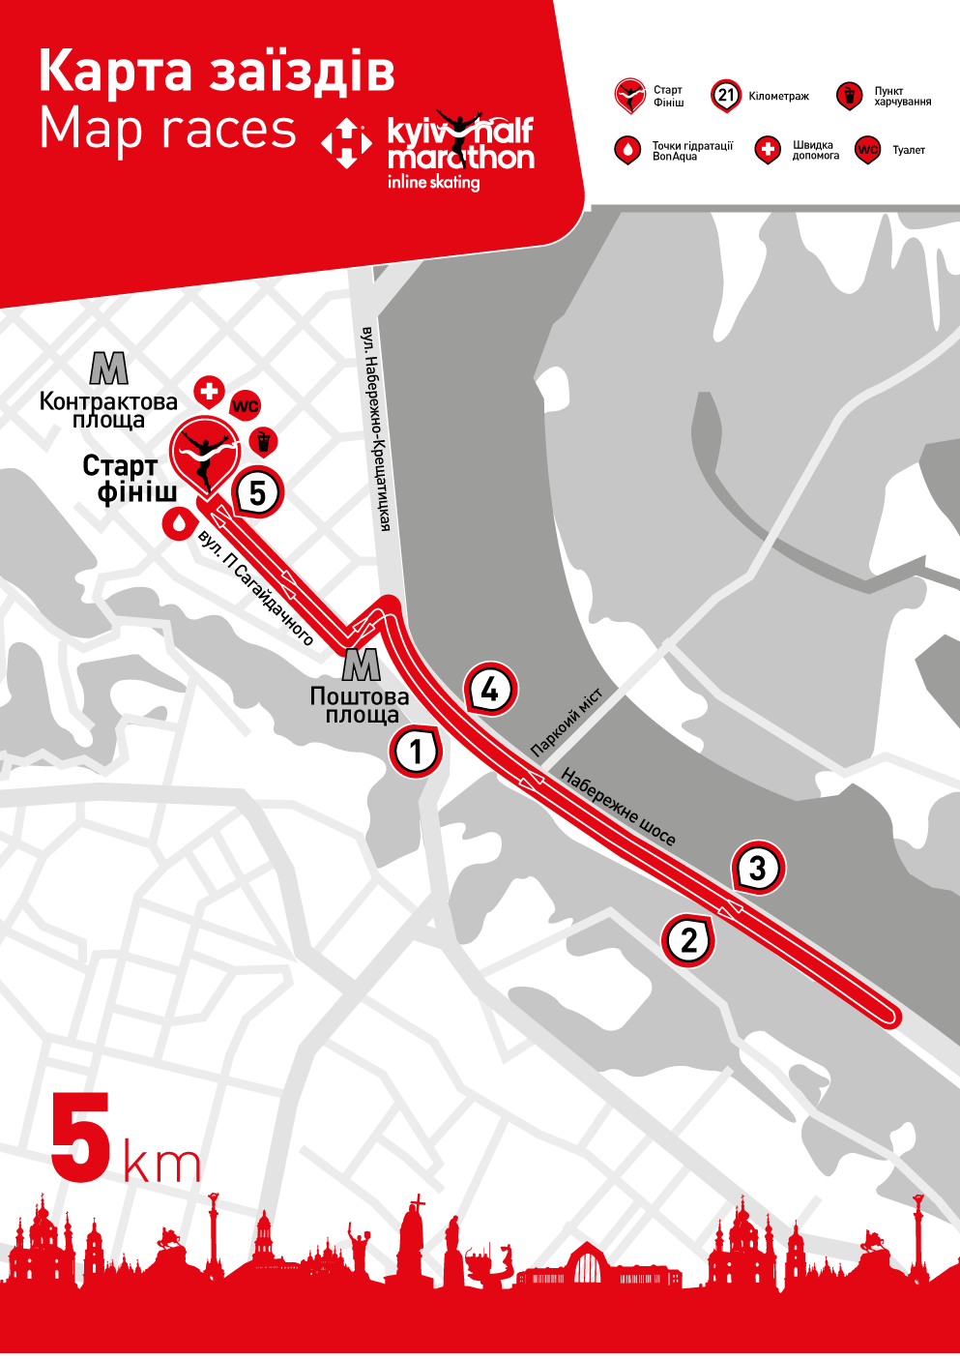
10. Registration
Participants are allowed to enter the race provided proper and timely registration for the race.
Registration is available on-line on the organizer's website www.kyivmarathon.org.
Online registration of participants will be open from October 6, 2015 till April 10, 2016.
There will be no registration on the day of the race.
The organizer of the Race has the right to suspend or completely close the registration without any prior notification in case of reaching an established limit of participants.
A participant is considered registered if an application is filled out and entry fee is paid.
The registration fee paid by participants is non-refundable no matter the circumstances. For instance, if an entrant is unable to compete on a course of choice or finish it within the given time limits; if a mandatory medical reference notice has not been provided, or in case of a disqualification; if the Race has been canceled due to unforeseen out of control circumstances, etc.
The registration is considered canceled in case submitted data is inaccurate and/or false. In case of registration cancellation entry fee is not refunded.
Paid registration can not be canceled, entry fees are non-refundable and non-transferable.
11. Entry Fee
21.0975 course entry fee by February 21, 2016 : 350 UAH
21.0975 course entry fee from February 22 to March 31, 2016: 450 UAH.
21.0975 course entry fee from April 1 to April 10, 2016: 550 UAH
5 course entry fee by February 21, 2016 : 300 UAH
5 course entry fee from February 22 to March 31, 2016: 350 UAH.
5 course entry fee from April 1 to April 10, 2016: 400 UAH

Money transfer commission is not included in the entry fee amount stated above.
Entry fee payment is to be made online using www.runukraine.org.

12. Refunding.
According to the public offer agreement signed by a participant at the end of the race registration process, funds paid to entry fee account are non-refundable.
13. Personal Data
Each entrant agrees to the use of personal data, photos, video or audio records reflecting their participation in the race for the purposes of advertising the event without the organizer having to obtain their consent and without any compensation followed.
All photo and video recordings of the Race accessible to the organizer can be used by them as supporting documentation confirming the accuracy of the race results, particularly, in case of any race rules violations.
14. Receiving Starter's Packages.
Handing out of "starter's packages" is carried out on April 15-16, 2016 at SportExpoUA 2016.
The 21.0975 km course participant "starter's package" includes:
• Race bib number
• Finisher medal
• Results capturing electronic chip
• Plastic backpack
• Changing rooms and lockers;
• Hydration stations: at 5, 10, 14 km and at the finish line
• Route map
• The Nova Poshta Kyiv Half Marathon 2016 Participant's Guide
• Special offers from our partners
• Official wristband of the Race
• Finisher's package: an apple, a banana, water
• Access to SportExpoUA 2016, an exhibition of sporting goods
The 5 km course participant "starter's package" includes:
• Race bib number
• Results capturing electronic chip
• Plastic backpack
• Changing rooms and lockers
• Hydration station: at the finish line
• Route map
• The Nova Poshta Kyiv Half Marathon 2016 Participant's Guide
• Special offers from our partners
• Official wristband of the Race
• Finisher's package: an apple, a banana, water
• Access to SportExpoUA 2016, an exhibition of sporting goods
The participant must pick up the starter's package on the designated handing out date. Starter's package ownership rights are transferred to the participant on the handing over date, regardless of his or her presence or absence. In case of no show, the organizers take on the responsibility of preserving the goods for one calendar month starting from the date of the race. During this month the participant can obtain it directly from the organizers or arrange to have it delivered by the courier service at his or her own expense. After one calendar month from the date of the race is over, the organizers withdraw any liability for the security of the product and become entitled to dispose of it at any moment.
Participants are to pick up starter's packages in person upon presenting the starting sheet and ID.
Participants that failed to use the opportunity to join the race can obtain their starter's package within 10 days after the competition at the organizer’s office, having preliminary sent notification about their intention to do so by e-mail: registration@runukraine.org. They also can place a request to have it delivered to a specified address.
Delivery of starter's packages is done at the expense of the participant. If possible, the organizer arranges for partners to provide free delivery.
15. Results Scoring System
The scoring service is provided and ensured by:
• Electronic timing system
• Referees with a manual timekeeping only for the first 5 men and 5 women.
Organizers warn that the electronic timing system has a certified results loss percentage, which is no more than 3% of the total chips number.
The Race Organizing Committee does not guarantee capturing each individual participant’s results in the following cases:
• Bib number attached incorrectly by the participant;
• Participant running with somebody else's bib number;
• Bib number being torn, wrinkled or damaged in any other way;
• Electronic chip being demagnetized, broken or damaged in any other way;
• Bib number lost.
Upon completing the overall distance the bib number must be preserved in the condition it was issued. It is strictly forbidden to remove, cover or damage it (cut, bend, etc.).
The organizer is to make the preliminary protocol of the Race results available no later than the next day after the actual event on the site www.kyivmarathon.org.
Participants may appeal against the preliminary results within 5 calendar days after the publication by email: registration@runukraine.org.
After this period, the preliminary results of the race (modified if necessary) are considered final.
16. Time Limit
In inline skating races time limit is set to:
• half marathon (21.0975km) – 1:10 hours;
• 5 km run - 35 minutes.
Participants who fail to comply with the time limits are disqualified from the race and can continue on their own outside of the race track (sidewalks, walkways, etc.) following the traffic rules of Ukraine.
17. Food and Hydration Stations
Hydration stations are located at 5; 10; 14 km and at the finish line. They have water, medical care, food, toilets and volunteer assistance availabe.
Food stations are located at the finish line.
18. Privileged Categories
Free registration is provided for combatants and war veterans, invalids of 1, 2 groups on 21.0975 km route.
18.1. Reduced registration for other categories of citizens of Ukraine:
• internally displaced persons from the ATO area ;
• seniors (women aged 55 or older and men aged 60 or older).
18.2. Special registration price:
• for the 21.0975 km course - 280 UAH;
• for the 5 km course - 240 UAH;
PLEASE, NOTICE: the cost of registration for privileged categories of participants does not change on February 23 and April 1, 2016 .
Participant must submit individual application by writing a letter to registration@runukraine.org, with the subject "Special Category". When submitting the application, you must enclose the documents according to your privilege: a copy of passport, pension ID, the certificate of combatant, the disabled pension certificate, a special certificate of internally displaced persons from the ATO area.
Registration packages and discounted registration are given out of specially allocated quota (maximum 5 people).
If there is a discrepancy found when registering a participant according to his or her claimed special category, the registration shall be canceled without any compensation from the organizers of the race.
YOU CAN RECEIVE YOUR FREE OR DISCOUNTED STARTER'S PACKAGE ON APRIL 15 OR 16 BY PROVIDING THE ORIGINAL COPY OF CERTIFICATE OF COMBATANT OR WAR/ATO VETERAN, DISABILITY CERTIFICATE, PENSION ID OR SPECIAL CERTIFICATE OF INTERNALLY DISPLACED PERSONS. YOU MUST PREVIOUSLY APPLY AT: registration@runukraine.org.
20. Procedure of Determining Award Winners and Medalists
The award winners and medalists of the competition among participants of inline skating races are determined according to best finishing time taking into account gender differentiation.
21. Award ceremony
The prize scale is determined by the organizers in every race at the discretion of the organizers.
The monetary reward should be paid to the determined medalists of the race in cash or by a non-cash transfer within 14 calendar days after the end of the race. The payment is made to the bank account of the winner or by cash at the office of organizers of the race, Kyiv, 52-Б Dmytrivska street, office 60. The monetary reward shall be paid only when the medalist provides originals and copies of their own documents: passport, individual tax code and application for payment of the reward. The medalist and the Organizer sign the appropriate document confirming the payment of reward.
The participant may be awarded late provided that the participant did not attend the award ceremony in his or her age group. In this case, the reward is sent by the organizer by mail to the address specified by the participant at registration.
Race Organizing Committee is not responsible for reward delivery if the participant indicated incorrect address.
All award winners and medalists receive prizes.
Marathon participant awarded in the absolute championship can not be awarded for a prize-winning place in his or her age group.
All participants of the marathon race finishing during the control time receive a medal at the finish line.
21.0975 km Course:
For the 21.0975 km course the award is given to those winning places 1 through 5 among men and women in absolute championship.
Prize scale (currency - UAH):
Place | Men | Women
1 | 10 000 | 10 000
2 | 8 000 | 8 000
3 | 5 000 | 5 000
4 | 2000 | 2000
5 | 1000 | 1000
For the 21.0975 km course (inline skating) there is no award in age groups,
For the 5 km course (inline skating) the award is given to those winning places 1 through 3 among men and women in absolute championship. The award winners and medalists receive prizes.
22. Protests and claims. Deadlines for protests and claims
The participant has a right to protest or submit a claim to the panel of judges, consisting of: the Head Referee, the Senior Referee of the starting-finish area and the Head Secretary.
Protests and claims may include:
• Protests and claims affecting the distribution of prizes;
• Protests and claims regarding inaccuracies in the measurement of the time the party took to run the distance;
• Protests and claims regarding disqualification for unsportsmanlike behavior.
The rest of the claims may be ignored by the panel due to lack of significance (this includes typos, incorrect personal data, etc.).
When submitting a claim, the participant must provide the following information:
• First and last name (anonymous claims will not be considered);
• Nature of claim (what the claim is about);
• Materials that prove error (photo, video).
The data of individual measuring timepieces will not be accepted.
Claims are only accepted from participants of the competition or from third parties that are official representatives of the participants.
Deadlines for protests and claims, and the manner of their presentation:
Protests and claims affecting the distribution of prizes in the absolute championship are accepted by the panel of judges in writing or orally starting with the announcement of winners and until the official awards ceremony.
Distribution of prizes may be reviewed by the panel of judges after the ceremony only if detecting violations of existing rules by the winner and if it was impossible to detect said violations before the awards ceremony.
The decision on the revision of distribution of prizes is made by the Race Director.
The participant has the right to protest or submit a claim on other matters within three calendar days after the end of the race.
Protest or claim is to be submitted in writing to the email address registration@runukraine.org.
23. Disqualification
The panel of judges reserves the right to disqualify a participant if:
• Participant ran under the registered number of another party;
• Participant cut the distance;
• Participant ran the distance for which he or she was not registered;
• Participant used improvised means of transportation (bike, scooter, auto, etc.);
• Participant started the race before the official start;
• Participant started the race after the strating line was closed;
• Participant ran to the finish line after the finish line was closed;
• Participant started the race not at the starting line;
• Participant ran without official race participant number;
• Participant displayed unsportsmanlike behavior.
24. Travel permit
The travel permits will be marked by a representative of the NGO "Rum Ukraine" only upon receiving the starter's package the day before the race.
25. Information sources
Details of the race can be found on the official site www.kyivhalfmarathon.org.
The Organizing Committee is not responsible for information on any other recources.

Appendix 1.
A complete list of institutions that provide medical certificates for admission to the Race of Nova Poshta Kyiv Half Marathon 2016
No | Name of institution  address | Telephone, fax,  e-mail | Head of institution
Volyn region
1. | Department of SM of Volyn Regional CH  43005, city Lutsk,  21 Prezydenta Hrushevskoho Av. | 033-223-02-63  033-277-31-36 tel/fax  uozvolyn@lt.ukrtel.net  kljudmila@myrambler | Kohut  Liudmyla Vasylivna  066-469-23-61
Vinnytsia region
2. | Vinnytsia RETD  21050, city Vinnytsia,  2 Hrushevskoho street | 043-235-22-96 tel/fax  fizdispanser@ukr.net  from 8.30 till 15.00 | Chernyshuk  Serhii Nykyforovych  096-331-19-16
Dnipropetrovsk region
3. | CE "Dnipropetrovsk ETD of Dnipropetrovsk RС"  49050, city Dnipropetrovsk,  3-A Yaroslavskoho street | 056-760-94-34 tel/fax  dvfd@ukr.net | Dukach  Lidiia Mykhailivna  056-760-94-34
4. | MHCI "City Medical CH and sports medicine"  51934, city Dniprodzerzhynsk,  4-A 9-ho Travnia street | 056-952-16-00  sport@ukrpost.net | Mukharska  Tetiana Yulianivna  067-582-62-08
5. | Department of SM of MI “City Hospital #1” of Dnipropetrovsk RC,  50051, city Kryvyi Rih  2 Ordzhonikidze street | 056-407-14-64  1doctor@mail.ru | Koliada  Anatoliy Pavlovych  097-166-92-85
6. | SM Consulting Room of MI “Pavlohrad City Hospital #1” of Dnipropetrovsk RC",  51400, city Pavlohrad,  63 Shevchenka street | 056-326-30-17  gorbolnichal@ucrpostа.uа | Lysetska  Liubov Petrivna  099–059–42–49
Donetsk region
7. | Department of SM of Central City Hospital #1  87500, city Mariupol,  80 Lenina Ave. | 0629-33-63-94  0629-33-65-92 | Frolova  Liudmyla Stepanivna  067-103-82-92
Zhytomyr region
8. | Regional Medical CH and SM of Zhytomyr RC  10003, city Zhytomyr,  10-А Maidan Peremohy | fax: 0412-22-87-27  tel: 0412-47-49-42  omc@ztomc.net.ua | Khrenov  Volodymyr Ivanovych  050-561-67-28
Zaporizhzhia region
9. | MI "Zaporizhzhia RETD"  69063, city Zaporizhzhia,  71 Hoholia street | 0617-17-21- 92  0617-17-21-93  igor.tkalich@gmail.com | Tkalich  Ihor Viacheslavovych  093-044-84-70
10. | Department of SM of MI "Melitopol City Children's Hospital" of Melitopol CC of Zaporizhzhia region  72319, city Melitopol,  21 Frolova street | 061-942-25-30  meldetbolnica@i.ua | Sereda  Petro Mykhailovych  097-972-65-22
Zakarpattia region
11. | Zakarpattia RETD  88000, city Uzhhorod,  15-А Timiriazieva street | 031-263-67-69 tel/fax  auship@ukr.net | Shyp  Andrii Yuriiovych  050-432-12-22
Ivano-Frankivsk region
12. | Ivano-Frankivsk regional ETHC  76006, city Ivano-Frankivsk,  20 Mateyka street | 034-272-34-75 tel/fax  sanos@meta.ua | Hrynevych  Roman Yosypovych  067-124-78-35
Kirovohrad region
13. | MI "RETD"  25006, city Kirovohrad,  42 Shevchenka street | 052-222-09-16  sportme@ukr.net | Davosyr  Ihor Zinoviiovych  067-803-09-60
14. | Department of SM of City Hospital #1  28000, city Oleksandriia,  77 Dibrova street | 052-357-37-40 - commutator  stat_oml@ukr.net | Khirsa  Nadiia Fedorivna  066-207-52-68
Kyiv region
15. | MI of Kyiv CC «Kyiv RETD»  04053, city Kyiv,  13/19 Nesterivskyi lane | 044-272-46-78 tel/fax  044-272-46-79 reception  medical_kiev@ukr.net  www//lfk-kiev.org.ua | Acting Head Kotenko Yuliya Ihorivna  050-384-81-48
16 | Department of SM № 2 of MI of Kyiv RC «Kyiv RETD»  09100, city Bila Tserkva,  52 Shevchenko street | 045-635-34-33 | Panteleimonova  Svitlana Petrivna  096-289-72-44
Lviv region
17. | MI of Lviv RC "Lviv RETD"  79044, city Lviv,  47 Konovaltsia street | 032-238-70-96 tel/fax  lolfdlviv@ukr.net | Sereda  Stepan Vasyliovych  067-967-65-78
Mykolaiv region
18. | RETD — municipal institution of Mykolaiv region  54017, city Mykolaiv,  39 Dunaieva street | 051-247-93-05 tel/fax  051-247-83-49 т.  ovfd.mk@ukr.net | Kravchuk  Tetiana Henrikhivna  050-707-10-25
Odesa region
19. | MI Odesa RETD  65012, city Odesa,  4 2nd Kulykivskyi lane | 048-785-19-82  048-725-91-10 tel/fax  oblvfd@mail.css.od.ua  с 08.30-14.00 | Acting Head Doctor  Dmytriiev  Oleh Arkadiiovych
Poltava region
20. | Poltava Regional Clinical ETD  36011, city Poltava,  23 Shevchenka street | 053-227-37-68 tel/fax  sheiko_petro@mail.ru  pofd_poltava@mail.ru | Sheiko  Petro Andriiovych  066-297-43-50
21. | Kremenchuk RETD  39602, city Kremenchuk,  26/41 60-richchia Zhovtnia street | 053-677-97-00  dispanser@lіnk-kremen.net | Sokolov  Serhii Yevhenovych  050-635-50-87
Rivne region
22. | Department of SM and ET of Viktor Polishchuk Rivne Regional Clinical DTC  33028, city Rivne, 36 16 Lypnia street | 036-263-37-35 tel/fax  08.00 до 16.00  obl-lik-fiz@rambler.ru | Vovchanska  Svitlana Yevhenivna  067-645-10-44
Sumy region
23. | MI of Sumy RC "Sumy Regional Clinical ETD"  40022, city Sumy,  44 Luchanska street | 054-266-11-80  fizdispanser67@mail.ru  08.00 до 16.00 | Acting Head Rodnikov  Viktor Viktorovych
Ternopil region
24. | Ternopil Regional Municipal ETD  46001, city Ternopil,  1А Staryi Rynok street | 035-252-64-72  035-225-37-58 tel/fax  oklfd_ternopil@ukr.net | Pankiv  Ihor Volodymyrovych
Kharkiv region
25. | MIHC Kharkiv RETD  61072, city Kharkiv,  63 Tobolska street | 057-340-33-09  057-340-25-4 tel/fax  kholfd@ukr.net | Kyryllov  Viktor Petrovych  067-573-80-55
Kherson region
26. | Kherson regional CH and SM  73005, city Kherson,  169 Perekopska street (P.O. box 56) | fax: 055-235-50-27  055-235-50-26  centersportmed@i.ua  romaskevichy@uk.net | Romaskevych  Yurii Oleksiiovych  067-416-27-08
Khmelnytskyi region
27. | SM Consulting Room of 1st City Polyclinic,  29013, city Khmelnytskyi,  54 Podilska street | fax: 038-265-52-02  tel: 038-279-43-42 1hospital@mail.ru (polyclinic) | Solovei  Alla Viktorivna  097-308-44-35
Chernihiv region
28. | Department of SM of CHCI “Chernihiv regional center of radiation protection and health of the population”  14020, city Chernihiv,  160 Shevchenka street | 046-295-39-02  сh_ocrzon@i.ua | Korobenko  Inna Volodymyrivna  093-191-10-80
Cherkasy region
29. | Department of ET and SM of MI "Cherkasy Regional Hospital of Chercasy RC"  18009, city Cherkasy,  25А Dakhnivska street | 047-237-03-52  047-237-62-92 tel/fax  oblkan@zdrav.ck.ua (hospital) | Holyk  Volodymyr Volodymyrovych  098-395-96-16
Chernivtsi region
30. | MI "RETD"  58022, city Chernivtsi,  3 Stetsenka street | 037-223-13-85 tel/fax  olfd.ukr@gmail.com | Kuryk  Mariia Vasylivna  050-934-76-38
Kyiv city
31. | MI "HC" of Holosiiv district of Kyiv city  03040, city Kyiv,  88 40-richchia Zhovtnia pr. | starting August 26, 2015  044-257-30-16  044-257-93-44 | Barkalova  Liudmyla Valiivna
32. | "HC" of Pecherskyi district of Kyiv city  01015, city Kyiv,  38 Moskovska street | 044-280-51-51  ресhсz@health.kiev.ua | Pohuliai  Hanna Viktorivna  067-124-69-75
33. | "HC" of Shhevchenkivskyi district of Kyiv city  04050, city Kyiv,  11 Biloruska street | 044-483-08-94  044-483-21-93  centrzdorov@ukr.net  centrsport@ukr.net | Shulha  Oleksandr Pavlovych  067-233-42-28

