Approved by  President of Odesa Regional Athletic Federation  ____________  Honcharenko O.  Head of the Department of Physical Education and Sport of the Odessa City Council  ____________  Puzdrach R.O. |  | Approved by  Director of NGO "Run Ukraine"  _______________  Chernitskyi D.L.
4th ODESA HALF MARATHON 2019
Regulations
1. Date, Time and Location.
Date: September 15, 2019
Time: 08:00 a.m.
Location: Odesa
Start and finish points: 1 Chaikovskoho Lane, by the Opera Theatre
2. Race Objectives
«ODESA HALF MARATHON» (hereinafter - the Race) is held to popularize and promote mass running events in Ukraine, as well as:
- to popularize and promote healthy lifestyle
- to develop mass sports
- to integrate Ukraine into the global marathon movement
- to inform, nurture and motivate Ukrainian public, to facilitate achievement of personal athletic goals, to stimulate growth of sports achievements among the country's wide grass-root population.
3. Organizers, Patronage and Sponsors.
NGO "Run Ukraine" serves as the Race Organizer.
Under the patronage of Odesa Regional Athletic Federation
The Organizer establishes an Organizing Committee from among its own staff, as well as engages different sport-specific specialists.
The Organizing Committee includes:
- Odesa City Mayor Trukhanov H. L. - Head of the Organizing Committee
- Race Director, Chernitskyi D.L.
- Project Manager, Tretiakov I.O.
- President of Odesa Regional Athletic Federation - Honcharenko O.
- Medical Director of the Race, Ked A.Yu.
- Chief Referee of the Race, Bilolypetskykh L.M., 1st category Judge
- Athletes Manager Lishchynska I. A.
4. Event Program
September 14, 2019:
10:00 - 20:00 - Distribution of starter’s packages to the participants

September 15, 2019:
07:00 - Opening of the «Race Village», Chaikovskoho Lane, by the Opera House.
07:00 - 15:00 - Luggage storage available;
07:30 - Warm-up for adults
07:50 - Opening of the starting block for the courses 21.0975 km, Relay | 3×5 km +1×6.0975 km, Team 4х21.0975 km
07:50 - Opening ceremony of Odesa Half Marathon 2019
08:00 - Start on the courses 21.0975 km, relay 3х5 km +1х6.0975 km, Team 4x21.0975 km;
08:20 - Start on the 4.2 km course;
11:15 - Start on the 10 km course;
15:00 - Closing of the “Race Village”
* The program is to be supplemented

You need to arrive at 1 Chaikovskogo Lane, by the Opera House, one hour before your race to have time to change, leave your luggage, find your starting block and warm up.

5. Race Entry Conditions
Participants may enter the Race in case they provide all the documents upon receiving the starter's package:
- A starter's letter printed out and signed by the participant (the starter's letter can be found in the personal profile or in the e-mail box after a successful payment);
- An ID certifying the age of the participant (required for all participants);
- A document certifying the right for free participation in the Race or for a discount payment of entry fees.
All registered participants bear sole responsibility for their own lives and health regarding the competition, and sign corresponding statement.
Participants aged 14 through 15 (for the course of 5 km) and participants aged 15 (for the course of 10 km) must also provide Parental (legal representative) consent to participation of a minor in the race on the courses of 5 km or 10 km (Annex 2 or Annex 3 respectively)
All registered participants bear sole responsibility for their own lives and health regarding the competition, and sign appropriate statement.

Please, notice!
Starter's package and participant's race bib number will not be provided in case of failure to provide a proper ID.
Only participants aged 18 or older are admitted to the courses of 21.0975 km. The age of a participant is determined as of December 31, 2019 based on submitted documents.
6. Courses and Routes
Route of the courses 21.0975 km / Relay | 3×5 km +1×6.0975 km / Team 4х21.0975 km
Track surface: 70 % - blacktop, 30 % - paving;
Total elevation gain - 100 meters.
The start and finish lines of all courses are located in the same spot.
Total number of laps – 1
PLEASE, NOTICE! The route may be altered!
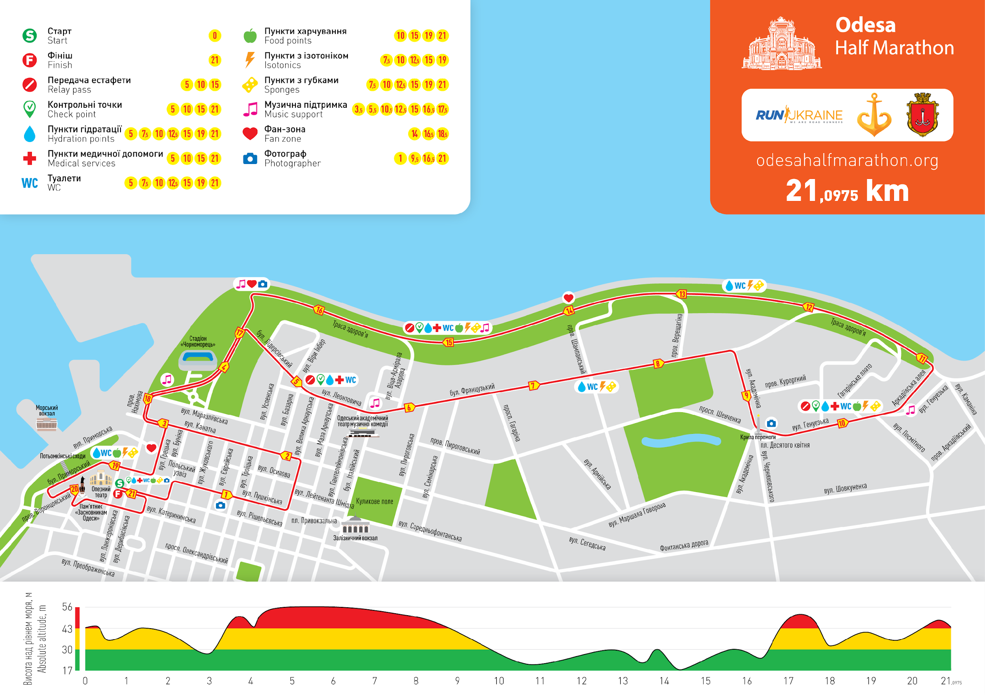
Route of the 10 km course:
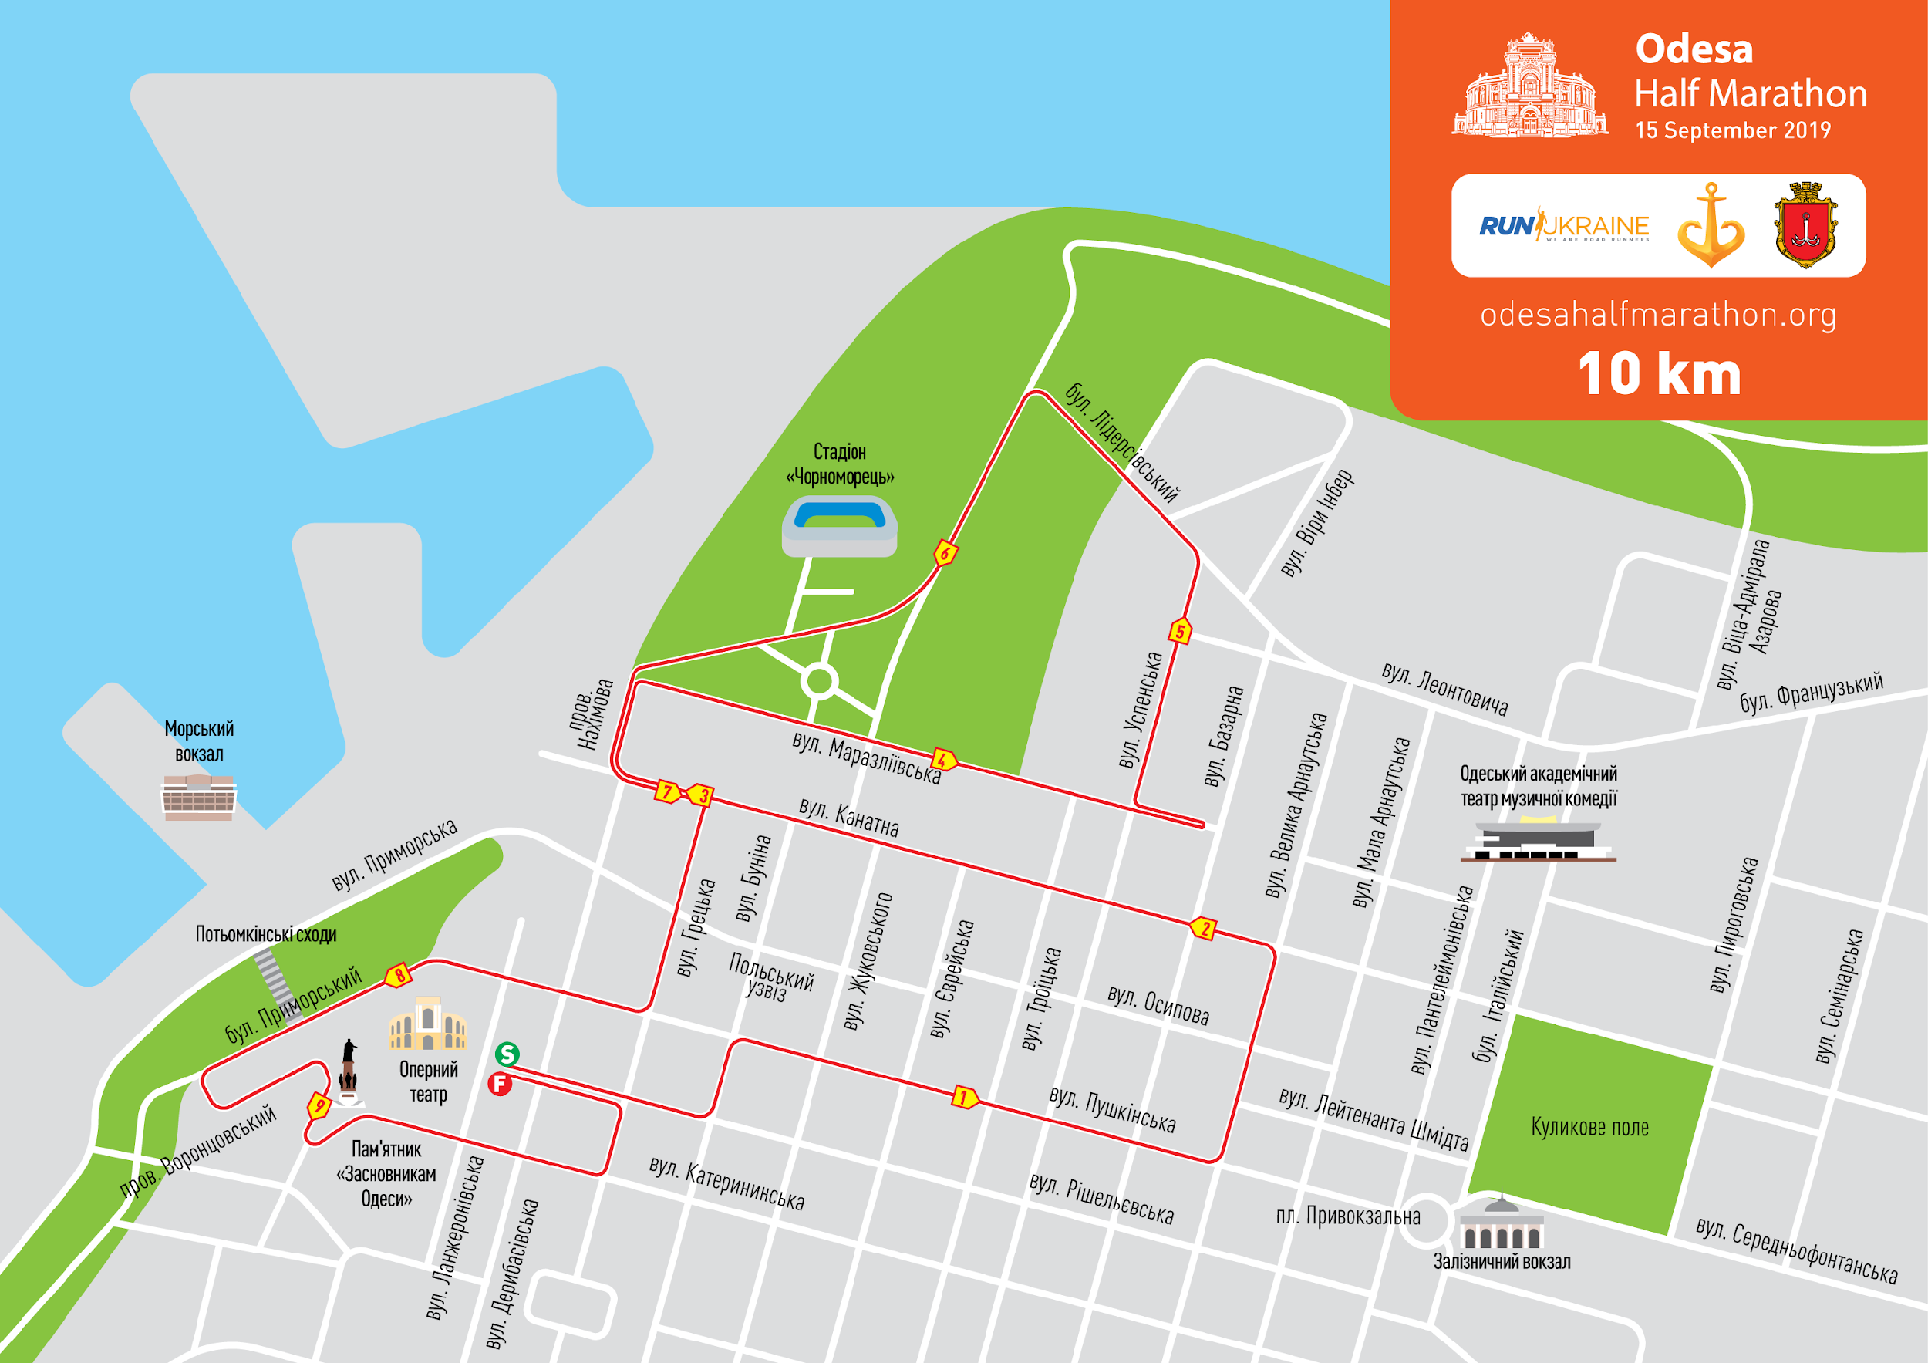
Route of the 4.2 km course:
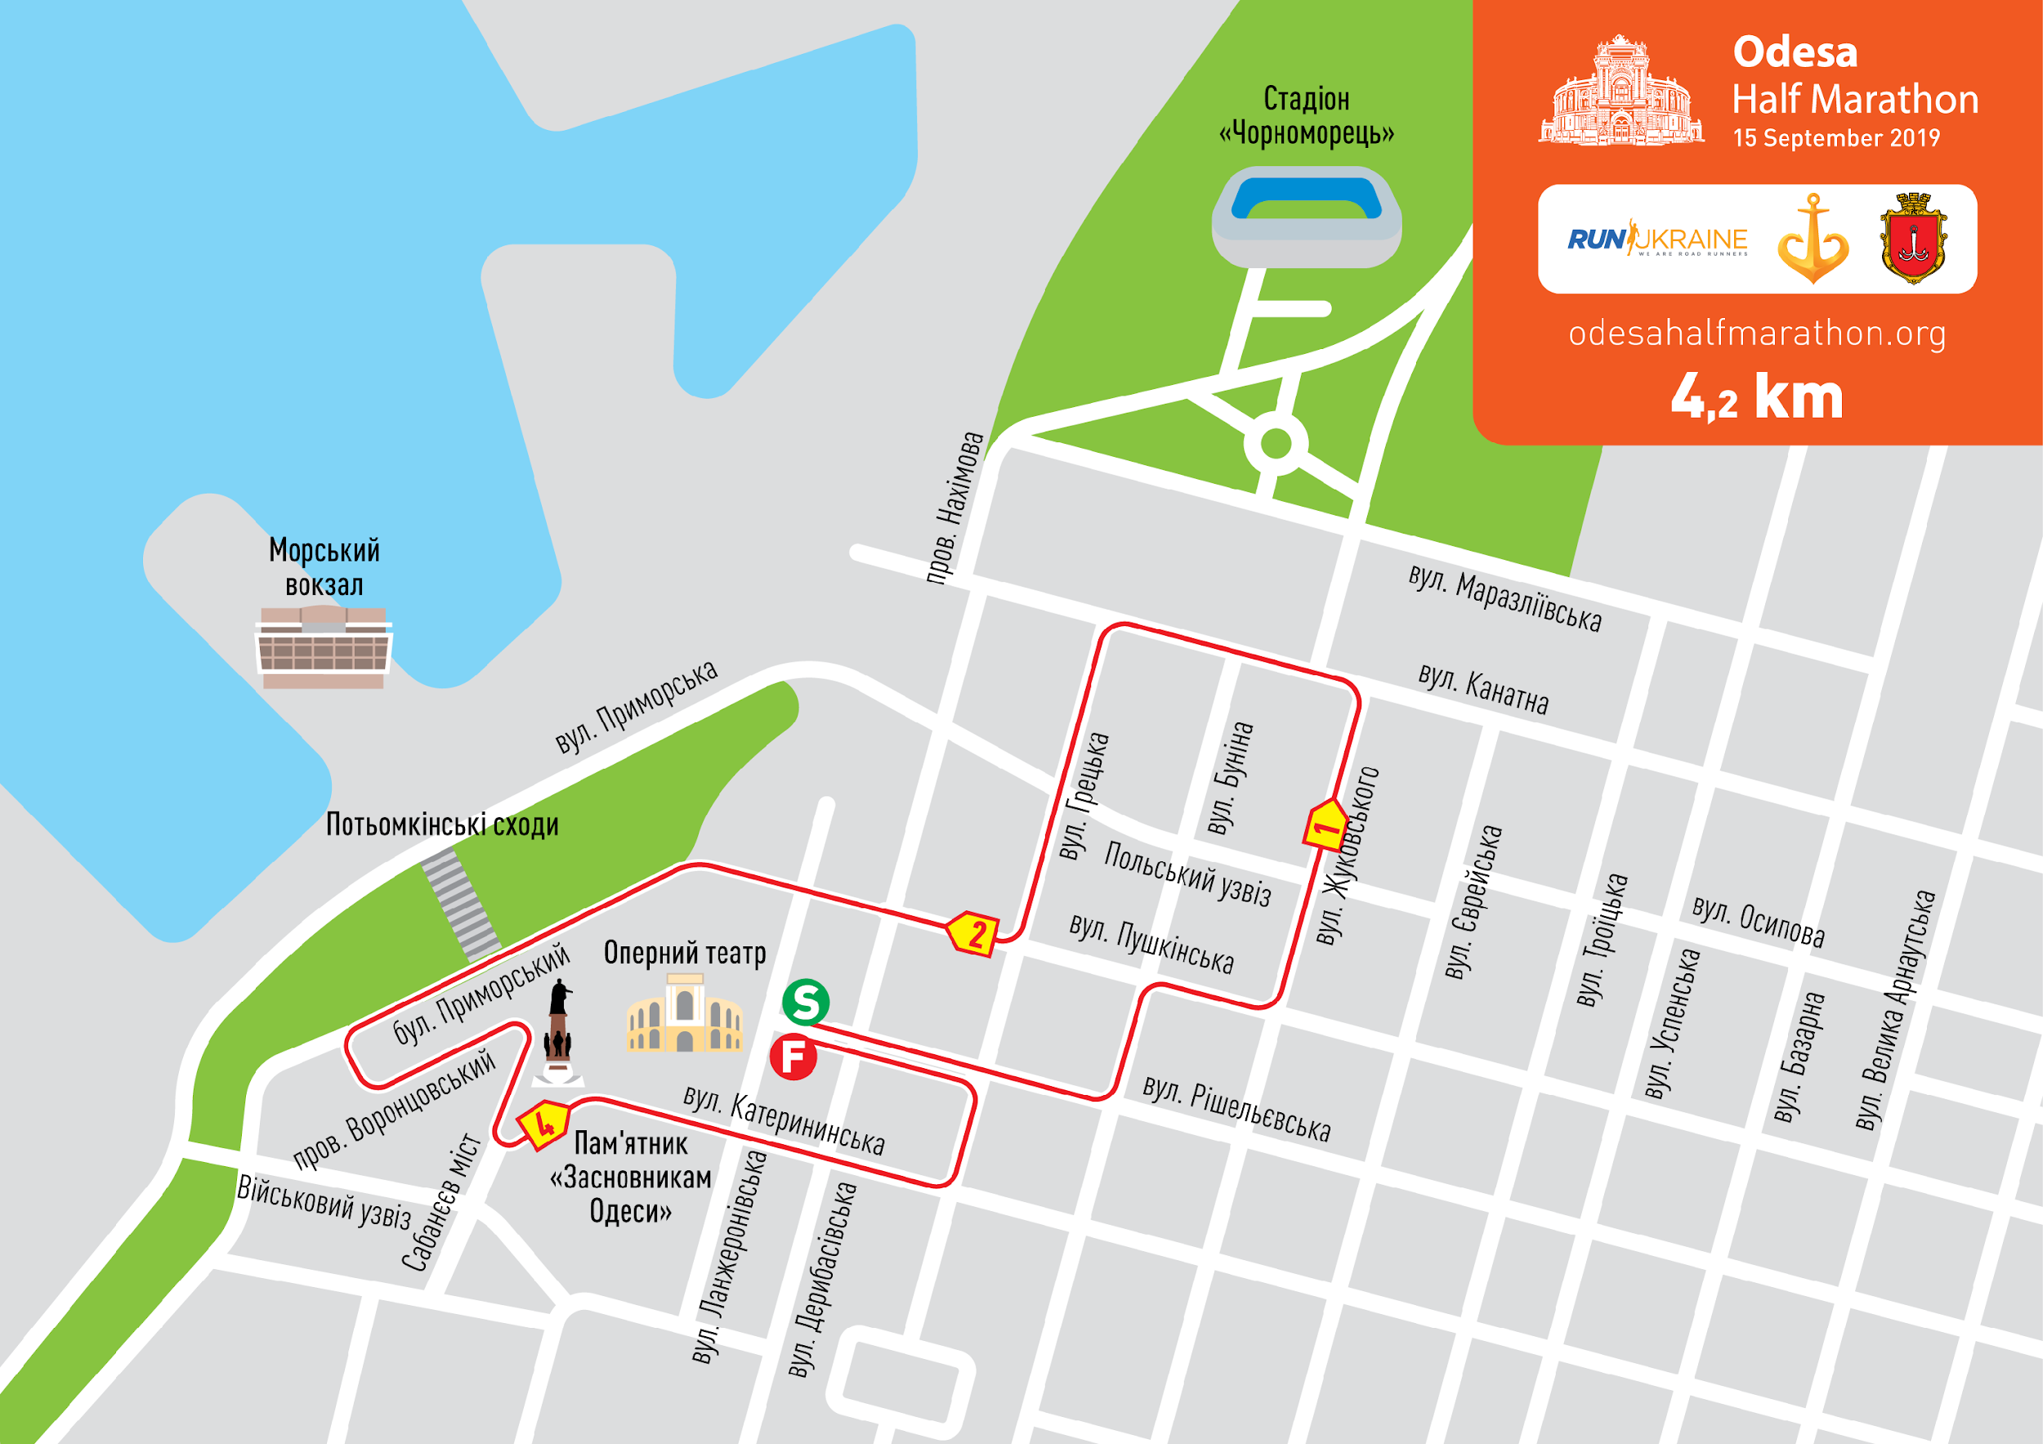
*The information is to be supplemented

7. Registration for the Race
Participants are allowed to enter the Race provided proper and timely registration for the Race.
Registration is available on-line on the Organizer's website http://odesahalfmarathon.org/
Online registration of participants is open from 11 December 2018 through 14 September 2019 (in case of available slots).
There will be no registration on the day of the Race.

The Organizer of the Race reserves the right to suspend or completely close the registration without any prior notification in case of reaching an established limit of participants.
A participant is considered registered if an application is filled out and entry fee is paid.
The registration fee paid by the participant is non-refundable no matter the circumstances. For instance, if a participant is unable to participate in the Race, to complete the course of choice or finish it within the given time limits or in case of disqualification or if the Race is cancelled due to force majeure circumstances, etc.
The registration is considered cancelled in case submitted data is inaccurate and/or false. In case of registration cancellation entry fee is not refunded.
Paid registration cannot be cancelled, entry fees are non-refundable.

7.1. The startert’s package may be given to the third party in case of provision of the following documents:
- Document certifying the identity of the person receiving the starter’s package (passport, driver’s license etc.)
- Copy of the documents certifying the identity of the person that purchased registration.
- Starter’s letter signed by the participant.
- Statement from the participant with the following text:

To the Director of NGO “Run Ukraine”
Chernitskyi D.L.
I, (last name and first name of the person that purchased registration), request my starter’s package with the participant’s number (provide you starting number) to be given to my representative (last name and first name of the representative receiving the package) due to the fact that I am unable to receive it in person.
Date and signature of the person that purchased registration
8. Entry Fee
Entry fee for the course of 21.0975 km is 499 UAH for members of NGO and 650 UAH basic fee until 10 February, 2019;
Entry fee for the course of 21.0975 km is 650 UAH for members of NGO and 815 UAH basic fee from 11 February, 2019 through 07 July, 2019;
Entry fee for the course of 21.0975 km is 800 UAH for members of NGO and 1,000 UAH basic fee from 08 July 2019 through 08 September, 2019
Entry fee for the course of 21.0975 km is 1100 UAH for members of NGO and 1320 UAH basic fee from 09 September, 2019 through 14 September, 2019.

Entry fee for the course of 10 km is 490 UAH for members of NGO and 590 UAH basic fee until 10 February, 2019;
Entry fee for the course of 10 km is 490 UAH for members of NGO and 590 UAH basic fee from 11 February, 2019 through 07 July, 2019;
Entry fee for the course of 10 km is 550 UAH for members of NGO and 660 UAH basic fee from 08 July 2019 through 08 September, 2019
Entry fee for the course of 10 km is 900 UAH for members of NGO and 1080 UAH basic fee from 09 September, 2019 through 14 September, 2019.

Entry fee for the course of 4.2 km is 399 UAH for members of NGO and 480 UAH basic fee until 07 July, 2019;
Entry fee for the course of 4.2 km is 499 UAH for members of NGO and 600 UAH basic fee from 08 July 2019 through 08 September, 2019
Entry fee for the course of 4.2 km is 700 UAH for members of NGO and 840 UAH basic fee from 09 September, 2019 through 14 September, 2019.

Entry fee for the course Team 4х21.0975 km is 1996 UAH for members of NGO and 2600 UAH basic fee until 10 February, 2019;
Entry fee for the course Team 4х21.0975 km is 2600 UAH for members of NGO and 3260 UAH basic fee from 11 February, 2019 through 07 July, 2019;
Entry fee for the course Team 4х21.0975 km is 3200 UAH for members of NGO and 4000 UAH basic fee from 08 July 2019 through 08 September, 2019
Entry fee for the course Team 4х21.0975 km is 4400 UAH for members of NGO and 5280 UAH basic fee from 09 September, 2019 through 14 September, 2019.

Entry fee for the relay 3х5+1х6.0975 km is 1996 UAH for members of NGO and 2600 UAH basic fee until 10 February, 2019;
Entry fee for the relay 3х5+1х6.0975 km is 2600 UAH for members of NGO and 3260 UAH basic fee from 11 February, 2019 through 07 July, 2019;
Entry fee for the relay 3х5+1х6.0975 km is 3200 UAH for members of NGO and 4000 UAH basic fee from 08 July 2019 through 08 September, 2019
Entry fee for the relay 3х5+1х6.0975 km is 4400 UAH for members of NGO and 5280 UAH basic fee from 09 September, 2019 through 14 September, 2019.

Money transfer commission is not included in the entry fee amount stated above.
Entry fee payment is to be made online using the Organizer's website www.runukraine.org.
9. Starter's Packages, Receiving Starter's Packages
The starter's packages will be distributed on September 14, 2019.

The "starter's package" of a participant on the course of 21.0975 km includes:
- Race bib number with participant's name (for those registered by August 14, 2019)
- Accident insurance for the day of the race
- Finisher's medal (awarded if the course is finished within the time limit)
- Results capturing electronic chip
- Plastic backpack
- Plastic top for the Start
- Changing rooms and luggage storage available
- Food stations at 5 km, 10 km, 15 km, 18 km and at the finish line
- Map of the route
- Odesa Half Marathon Participant’s Guide
- Special offers from the partners
- Music along the route
- Official event wristband
- Finisher's package: an apple, a banana, water, refreshment stations along the route
- Admission to sport goods exhibition SportExpoUA 2019

The "starter's package" of a participant on the course of 10 km includes:
- Race bib number with participant's name (for those registered by August 14, 2019)
- Accident insurance for the day of the race
- Finisher's medal (awarded if the course is finished within the time limit)
- Results capturing electronic chip
- Plastic backpack
- Changing rooms and luggage storage available
- Hydration stations at 5 km and at the finish line
- Map of the route
- Odesa Half Marathon Participant’s Guide
- Special offers from the partners
- Music along the route
- Official event wristband
- Finisher's package: an apple, a banana, water, refreshment stations along the route
- Admission to sport goods exhibition SportExpoUA 2019

The "starter's package" of a participant on the course of 4.2 km includes:
- Race bib number with participant's name (for those registered by August 14, 2019)
- Accident insurance for the day of the race
- Results capturing electronic chip
- Plastic backpack
- Changing rooms and luggage storage available
- Food stations at the finish line
- Map of the route
- Odesa Half Marathon Participant’s Guide
- Special offers from the partners
- Music along the route
- Official event wristband
- Finisher's package: an apple, a banana, water
- Admission to sport goods exhibition SportExpoUA 2019

The "starter's package" of a participant on the relay course 3x5+1x6.0975 km includes:
- Race bib number with participant's name (for those registered by August 14, 2019) - 4 pcs.
- Finisher's medal (awarded if the course is finished within the time limit) - 4 pcs.
- Accident insurance for the day of the race - 4 pcs.
- Results capturing electronic chip - 1 per team
- Plastic backpack - 4 pcs.
- Plastic top for the Start - 4 pcs.
- Changing rooms and luggage storage available
- Food stations at 5 km, 10 km, 15 km, 18 km and at the finish line
- Map of the route
- Odesa Half Marathon Participant’s Guide - 4 pcs.
- Special offers from the partners
- Music along the route
- Official event wristband
- Finisher's package: an apple, a banana, water
- Admission to OpenRun Day
- Admission to sport goods exhibition SportExpoUA 2019

The "starter's package" of a participant for the course Team 4х21.0975 km includes:
- Race bib number with participant's name (for those registered by August 14, 2019) - 4 pcs.
- Finisher's medal (awarded if the course is finished within the time limit) - 4 pcs.
- Accident insurance for the day of the race - 4 pcs.
- Results capturing electronic chip - 1 per team
- Plastic backpack - 4 pcs.
- Plastic top for the Start - 4 pcs.
- Changing rooms and luggage storage available
- Food stations at 5 km, 10 km, 15 km, 18 km and at the finish line
- Map of the route
- Odesa Half Marathon Participant’s Guide - 4 pcs.
- Special offers from the partners
- Music along the route
- Official event wristband
- Finisher's package: an apple, a banana, water
- Admission to Open Run Day
- Admission to sport goods exhibition SportExpoUA 2019

The "starter's package" of a participant on the course of 4.2 km includes:
- Race bib number with participant's name (for those registered by August 14, 2019)
- Accident insurance for the day of the race
- Results capturing electronic chip
- Plastic backpack
- Changing rooms and luggage storage available
- Hydration stations at 5 km and at the finish line
- Map of the route
- Odesa Half Marathon Participant’s Guide
- Special offers from the partners
- Music along the route
- Official event wristband
- Finisher's package: an apple, a banana, water, refreshment stations along the route
- Admission to sport goods exhibition SportExpoUA 2019

The participant must pick up his/her starter's package on the designated distribution date. Starter's package ownership rights are transferred to the participant on the distribution date, regardless of his or her presence or absence. In case of no show, the Organizers take on the responsibility of preserving the goods for one calendar month starting from the date of the Race. During this month the participant can obtain it directly from the Organizers or arrange to have it delivered by the courier service at his or her own expense. After one calendar month from the date of the Race is over, the Organizers withdraw any liability for the security of the product and become entitled to dispose of it at any moment.
Participants are to pick up starter's packages in person upon presenting the starting letter and ID.
Participants that failed to join the Race can obtain their starter's package within 30 days after the competition at the Organizer’s office, having preliminary sent notification about their intention to do so by e-mail: registration@runukraine.org. They also can place a request to have it delivered to a specified address.
Delivery of starter's packages is done at the expense of the participant. If possible, the Organizer arranges for partners to provide free delivery.
10. Team competitions (teams and relay) of athletes
Mixed teams from commercial and non-profit organizations consisting of 4 persons are permitted to participate in the relay.
If the organization can not find 4 members from inside organization, it can invite volunteers.
In the relay race participation of all four team members is mandatory.
The team is considered registered if its representative filled out the application, registration form and paid the entry fee for the team.
The procedure of assigning participants with a particular stage of relay is performed at registration. The order of participants can be changed through September 13, 2019 in your personal profile on the website runukraine.org.

For participant’s information:
- During the relay race the procedure of the baton transfer should take place only in the transfer zone.
- Each team gets ONE result capturing electronic chip.
- The chip is attached to the leg and passed on in the relay transfer zone.
- The first participant comes to the starting line with the chip attached to the leg.
- Team members are not allowed to change their numbers.
- Relay participants run in the order stated at registration.
- Finisher’s medals for all stages are given to the participant of the last stage upon crossing the finish line.
- A finisher’s package (an apple, a banana) is given to each participant upon finishing his/her stage

Infringement of any of the above rules will result in disqualification of the entire team.
The result of the last participant at the finish of the fourth stage of the relay is considered to be the result of the relay.
The result of the team scoring is the sum of the official results of all four team members.
Payment for participation in the corporate relay is performed by bank transfer on the basis of invoice issued by the Organizers. Documents confirming the payment should be sent to the email registration@runukraine.org no later than 10 days prior to the event. All questions in regard to organization of corporate relay are to be sent to the email address registration@runukraine.org.

10.1 For corporate teams:
There are several options of participation for companies:
- Team participation (any course and any number of participants);
- Chamber Cup (relay 3x5 km + 1x6 km)

Chamber Cup:
Mixed teams from commercial and non-profit organizations are permitted to participate in the relay.
Organization may form one or more teams for a corporate relay. The number of teams from one organization is unlimited.
The Chamber Cup will include an award ceremony for the winning teams in specific business segments with a separate ranking on the event website. Company’s name will be placed on the Chamber Cup participants’ bib number.
Attention!
- The teams taking places 1, 2 and 3 in the Chamber Cup will not be awarded.
- Chamber Cup teams will also take part in the overall ranking of relay teams.
- If a segment has up to 5 teams, there is no awarding in the segment, the teams will only be included in the overall ranking

Security Cup - 4.2 km:
Mixed teams of commercial and non-profit organizations (from the field of civil security) are permitted to participate in the race:
- Free participation
- Maximum number of participants in a team - 4 people
- Maximum number of teams from one non-profit organization - 3 teams
- Total number of participants - 48 people (12 teams)
Security Cup will determine winners and have award ceremony for men and women that won 1, 2 and 3 places.
They will also determine the winning team and award the team for winning the 1st place.
Also Security Cup teams will take part in the overall ranking among men and women on the 4.2 km course.

In case of questions regarding terms of registration, please email e.seitasanova@runukraine.org
Contact person: Elvina Seitasanova +38(067) 569-81-23
11. Food and Hydration Stations
Food stations and hydration stations are located at 5; 10; 15; 18 km and at the finish line. They have water, medical care, food, toilets and volunteer assistance available.

12. Award ceremony
21.0975 km course:
For the 21.0975 km course the award is given to those winning places 1 through 5 among men and women in absolute championship.
The official time used for the overall ranking among men and women is Gun Time.

Prize scale (currency – hryvnia, UAH):

Place | Men | Women
1 | 8000 | 8000
2 | 6000 | 6000
3 | 4500 | 4500
4 | 3500 | 3500
5 | 2500 | 2500

Track record: 5000 UAH for each category (men and women). Men track record: 1:07:432, Women track record: 1:18:22.5.
Bonus for setting time: 5000 UAH for each category (men and women). Men: 1:06:00, Women: 1:15:00.

For the 21.0975 km course the award is given in age groups, places 1 through 3:
Men: 18-22, 23-29, 30-39, 40-49 50-59, 60-69, 70 and older
Women: 18-22, 23-29, 30-39, 40-49, 50-59, 60-69, 70 and older
The age group is assigned based on the age of the participant as of December 31 of the current year. The winners awarded in absolute championship are not awarded in age groups. The places in age groups are awarded based on the Net Time.
Award winners and medalists receive monetary rewards and prizes.

Age group | Men |  |  | Women
 | 1 place | 2 place | 3 place | 1 place | 2 place | 3 place
18-22 | 1200 | 800 | 500 | 1200 | 800 | 500
23-29 | 1200 | 800 | 500 | 1200 | 800 | 500
30-39 | 1200 | 800 | 500 | 1200 | 800 | 500
40-49 | 1200 | 800 | 500 | 1200 | 800 | 500
50-59 | 1200 | 800 | 500 | 1200 | 800 | 500
60-69 | 1200 | 800 | 500 | 1200 | 800 | 500
70+ | 1200 | 800 | 500 | 1200 | 800 | 500

Please, notice:
- the absolute championship winners of the course 21.0975 km places 1 through 5 among men and women cannot be awarded in age groups
- Participants participating in wheelchairs or using any other mechanical device on the course may not be awarded in absolute championship or in age groups on any course

10 km course
For the 10 km course the award is given to those winning places 1 through 3.
The award winners and medalists receive prizes.
4.2 km course
For the 10 km course the award is given to those winning places 1 through 3.
The award winners and medalists receive prizes.
The official time used to determine the overall ranking among men and women is Gun Time.
Participants of the Security Cup category are included in the overall ranking among men and women on the 4.2 km course.

Team 4 х 21.0975 km:
The official time used to determine the overall ranking among the teams is the sum of the finishing time (Gun Time) of all 4 team members
On the course of 21.0975 km the award is given to the teams taking places 1 through 3.
6000 UAH – for the team taking the 1st place
4000 UAH – for the team taking the 2nd place
2000 UAH – for the team taking the 3rd place

Relay
For the relay 3x5+1x6.0975 km, including ChamberCup, the award is given to teams winning places 1 through 3 in absolute championship.
Winners and medalists receive monetary rewards and prizes.
1st place – 8000 UAH for the team
2nd place - memorable prize
3rd place - memorable prize

City Cup
The Cup is awarded to those demonstrating the best time on the course 21.0975 km among athletes that stated “Odesa” as their city on the registration form. Men and women awarded separately.

Nomination “The biggest running club”
Award for the running club which reached the maximum number of registered participants of the Race on any course.

